

**[](http://www.lifehack.org/articles/communication/even-the-darkest-night-will-end-and-the-sun-will.html?ref=pp)Looking after yourself during COVID19**

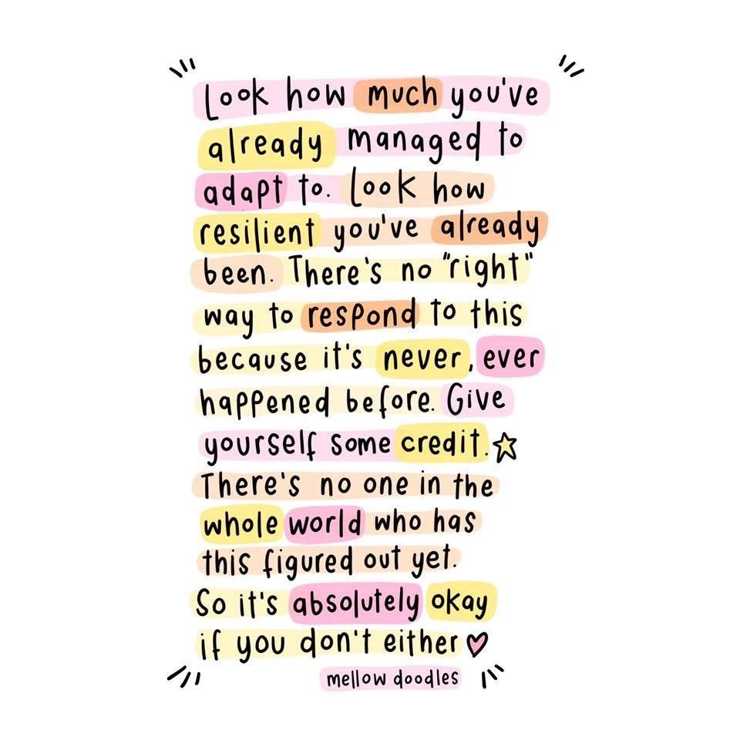It can be really difficult to notice the positive things when life is so unsettled. I have put together a list of things you can practice to try and alleviate some of your anxieties as we face this global crisis together. I hope you find them helpful ☺

* Make a plan to help you keep calm and stay in contact with your family and friends
* Send a letter or message to someone you can’t be with
* Thank 3 people you’re grateful for and tell them why
* Take a small step towards an important goal
* Write down 10 things you feel grateful for and why
* Share what you are feeling and ask for help if you need to
* Take 5 minutes to sit still and breathe. Repeat regularly
* Call a loved one to catch up
* Notice 5 things that are beautiful in the world around you
* Immerse yourself in a new book, TV show or podcast
* Play a game that you enjoyed when you were younger
* Learn something new or do something creative
* ***Remember that all feelings and situations pass in time***

**Taking care of your mental health and wellbeing**

[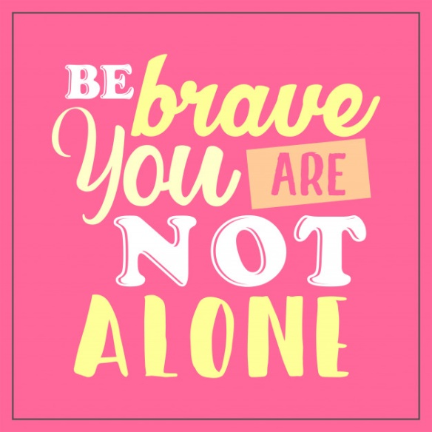](https://www.google.com/url?sa=i&url=https://www.freepik.com/premium-vector/be-brave-you-are-alone-quotes-typography_2028092.htm&psig=AOvVaw38lArz9b9USR9sfd-WKkjd&ust=1585671260737000&source=images&cd=vfe&ved=0CAIQjRxqFwoTCIiu9_PLwugCFQAAAAAdAAAAABAE)As you are staying at home more than you usually would, it might feel more difficult than usual to take care of your mental health and well-being. These are some ideas that may help:

**Hand washing and anxiety –** Some mental health problems can cause difficult feelings or behaviours to do with washing and hygiene. If you’re experiencing this, you may find it hard to hear advice about washing your hands. If this is making you stressed or anxious, here are some things you can try.

* Don’t keep reading the same advice if this is unhelpful for you
* Let other people know you’re struggling. For example, you could ask them not to remind you to wash your hands
* Plan something to do after washing your hands. This could help distract you and change your focus
* ****Set limits, like washing your hands for the recommended 20 seconds
* Breathing exercises can help you cope and feel more in control. You can find simple breathing exercises by typing this into google. Youtube also have some lovely meditations

**Connect with people –** Connecting with people is so important and can remind you that you aren’t alone in this situation.

* Make plans to video chat with people or groups you would normally see in person (Facetime, House party, Zoom, Skype)
* You can also arrange phone calls or send texts
* If you’re worried that you might run out of things to talk about, make a plan with someone to watch a show, read a book, play a quiz etc.
* Think of other ways to keep in contact with people while meeting in person isn’t possible. You could check your phone numbers are up to date, or that you have current email addresses/post addresses for friends you’ve not seen for a while.
* Connect with others who are in similar situations. The Eating Disorder Charity Beat have set up The Sanctuary, an online group created specifically in response to the Covid19 situation. This is a safe space for people with an eating disorder to share concerns and advice on how they are coping with the pandemic. ***Eating disorders thrive in isolation***, so it’s important to stay connected and support each other through this. You can access this by visiting the following link: ****<https://www.beateatingdisorders.org.uk/sanctuary>
* If you’re worried about loneliness, think of things you could do to connect with people. For example: putting up extra photos of your family and friends, listen to a radio station if your home feels too quiet.

**Decide on your routine –** It’s very important to follow a routine as this can help to lift your mood. Below are some things you could try:

* Plan how you’ll spend your time. It might help to write this down on a piece of paper and put it on the wall.
* Follow your ordinary routine as much as possible. Try to get up at the same time, following your usual morning routines, and go to bed at the same time.
* It can help to break up your day with something that makes you smile (a TV series, a craft activity, talking to friends etc)

**Get as much sunlight, fresh air and nature as you can –** If you able, try and sit in the garden. Bringing nature into your everyday life can benefit physical and mental well-being.

* Notice things around you and try to observe things through your senses (what you can see, feel, hear, touch and smell)
* You can also get the positive effects of nature whilst staying indoors at home. Spend time with the window open and let the fresh air in
* Sit s****omewhere comfortable, for example, by the window where you can look out over the view of trees or sky, or watch the birds and other animals.
* Look at photos that make you smile. Use them as background on your mobile phone or computer screen or print and put them up on your walls
* Listen to nature sounds, like recordings or apps that play birdsong, ocean waves or rainfall
* Get as much natural light as you can.
* If you have safe access to a green space like a garden, you can bring some natural materials in to decorate your living space or use them in art projects.
* You may be able to buy seeds, flowers or plants online for delivery, to grow and keep indoors. If you order items for delivery, ask to have them left at your doorstep, to avoid face-to-face contact.

**Find ways to spend your time –** There can be lots of things you can do to try and occupy your time.

* Try having a clear out. You could sort through your possessions and put them away tidily, or have a spring clean!
* **[](http://www.thegirlcreative.com/inspiring-wall-art-for-kids-kids-prints-series/)**Digital clear outs are always a good ide****a. Sort through photos, put them into albums, delete apps you don’t use, update all your passwords, or clear out your inbox
* Write letters/emails or make phone calls with people you’ve been meaning to catch up with

**Find ways to relax and be creative –** There are lots of different ways that you can relax. Take notice of the present moment and use your creative side. These could include:

* Mindful colouring
* Arts and crafts, such as drawing, painting, collage, sewing, craft kits or upcycling
* DIY
* Mindfulness
* Playing musical instruments, singing or listening to music
* Writing
* Yoga (if your clinician has said it’s safe to do so)

**Keep your mind stimulated –** Try to keep your brain occupied and challenged. Set aside time in your routine for this. Below are some ideas:

* Read books, magazines and articles. Listen to podcasts, watch films and do puzzles
* Although high street library branches are closed, some libraries have apps you can use online. These allow you to borrow ebooks, audiobooks or magazines from home for free, if you’re a library member
* FutureLearn and OpenLearn have free online courses you could try.
* There are lots of apps that can help you learn things, such as a foreign language or another new skill

**Take care with news and information –** It’s hard to get away from the news at the moment. You may find it helpful to stay connected to current events but please be careful where you get the news and health information from.

* For up to date advice in England, see the NHS coronavirus webpage.
* If news stories make you feel anxious or confused, think about switching off or limiting what you look at for a while.
* Social media could help you stay in touch with people but might make you feel anxious especially if people are sharing news stories or posting about their worries. Consider taking a break or limiting how you use social media. You might decide to view particular groups or pages but not scroll through timelines or newsfeeds

**If you’re feeling anxious –** It is completely normal to feel scared, overwhelmed and anxious, in fact any feeling your feeling is normal.

* It could help to plan a safe space in your home that you can go to if you feel overwhelmed. Make sure you have things here that help you to relax
* You can also find ways to comfort yourself if you’re feeling anxious. There are various games and puzzles you can use to distract yourself - <https://www.mind.org.uk/need-urgent-help/how-can-i-distract-myself/games-and-puzzles/> or breathing exercises <https://www.mind.org.uk/information-support/types-of-mental-health-problems/anxiety-and-panic-attacks/self-care-for-anxiety/>

**[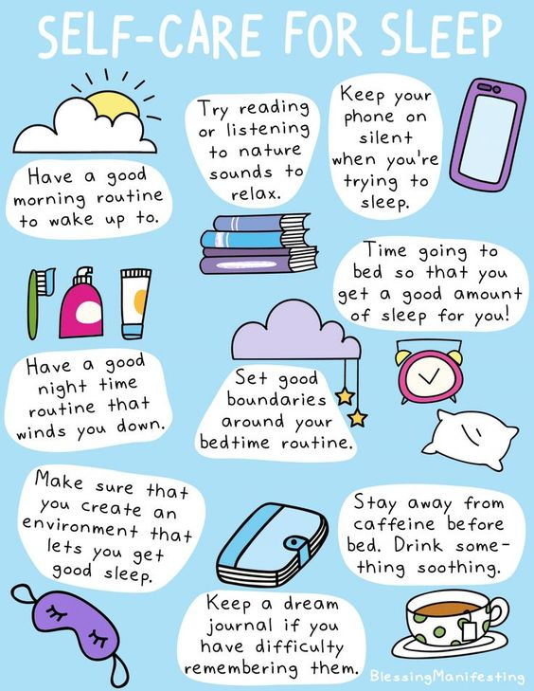](https://www.blessingmanifesting.com/2012/01/self-care-sleep.html/)**

**Mindful breathing**

The most basic way to do mindful breathing is to simply focus your attention on your breath, the inhale and the exhale. The primary goal of mindful breathing is simply a calm, non-judging awareness, allowing thoughts and feelings to come and go without getting caught up in them. If you haven’t done this before, it may take a little while to get used to it so I recommend starting slowly (5 minutes to start with) and then working up if you find it helpful.

The lotus flower can be used as a guided meditation. Imagine your heart as the flower unfolding in the centre of your chest. Inhale and exhale, concentrating your mind on your heart and your chest and the rhythmic motion of your breathing.

[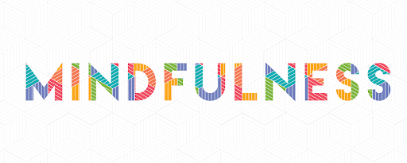](https://www.google.com/url?sa=i&url=http://theimprovegroup.com/blog/2018-01/2018-year-mindfulness&psig=AOvVaw3TkCdDNRbIe_heuTkEx5PG&ust=1585662955586000&source=images&cd=vfe&ved=0CAIQjRxqFwoTCIjb7fuswugCFQAAAAAdAAAAABAE)As you breathe in, imagine the lotus flower inside your chest is opening up its petals and expanding itself outwards. As you breathe out, bring yourself inside of the lotus flower and settle your mind, thoughts and feelings in that one place. Allow your feelings to pass through you, or imagine them settling on the petals of the flower.

When you have finished the meditation, take a moment of gratitude or reflection to solidify the positive and loving feelings within the flower and within you.

****Whenever you need to, return to the image of the lotus flower and the love within your heart and find that inner feeling of calm and peace again throughout the day.

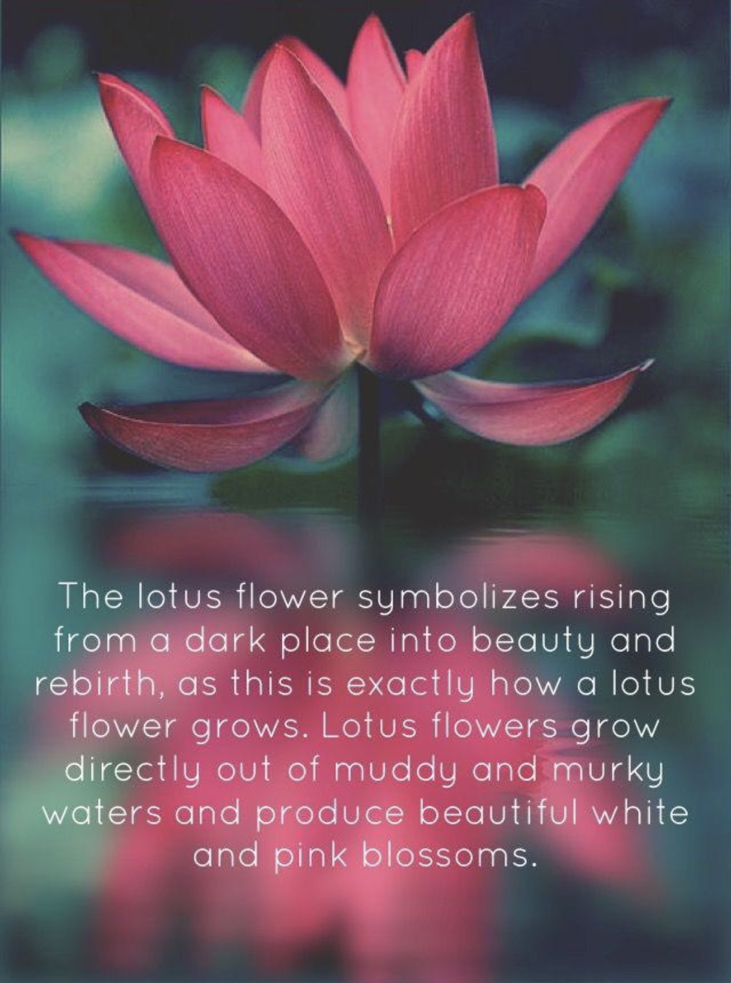



**Mindful colouring**

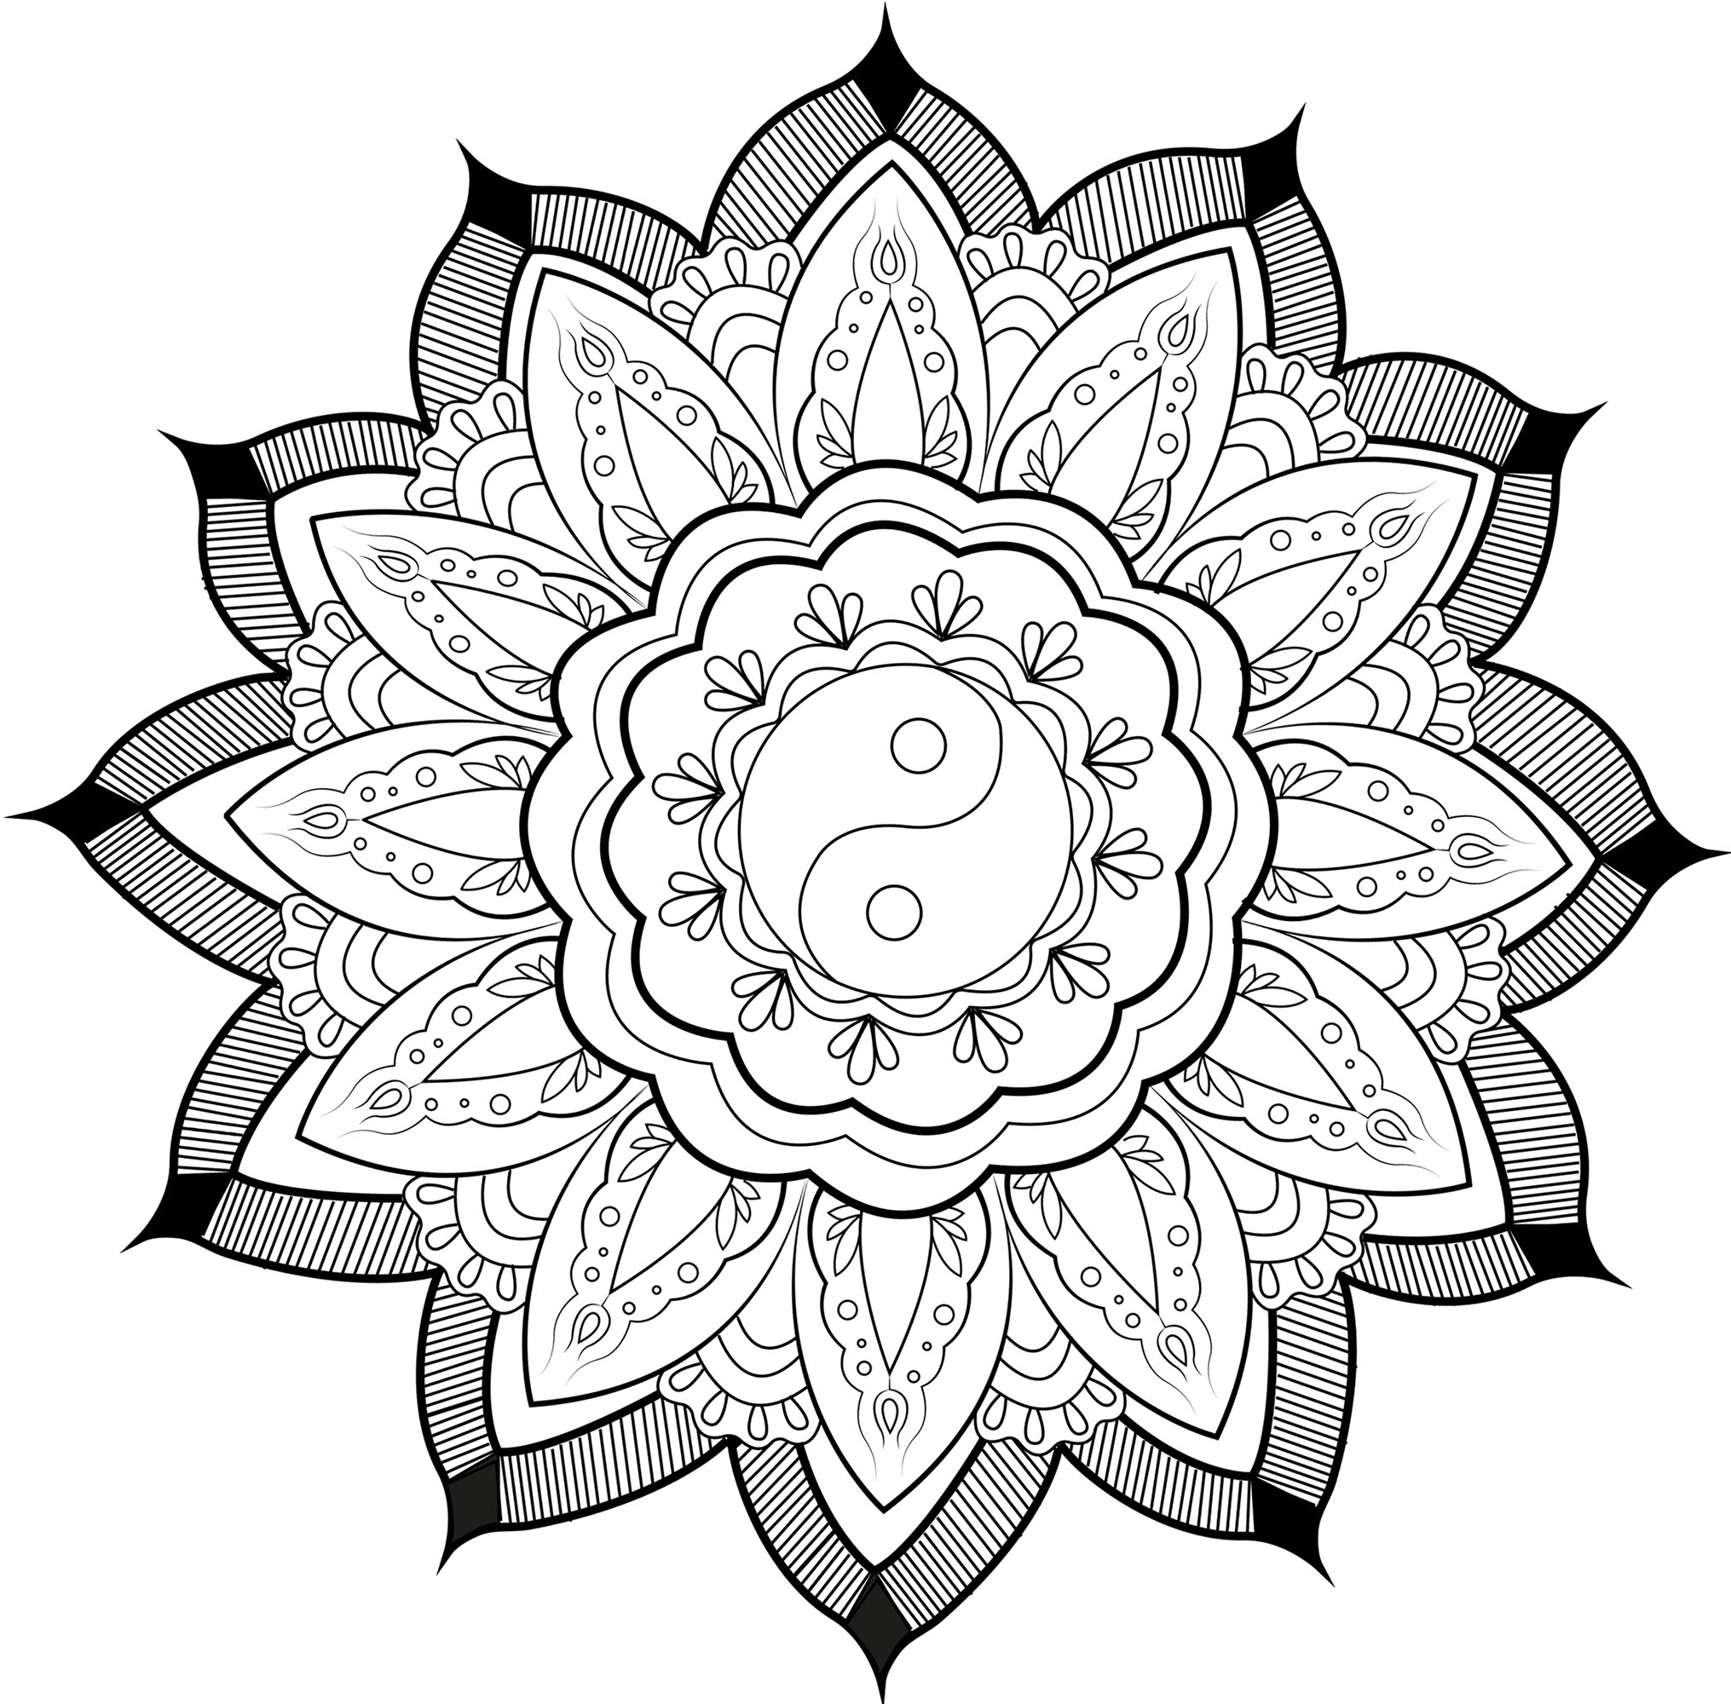Research suggests that mindful colouring can prove numerous benefits for all ages. Along with providing a much needed break and the chance to relax and refocus, it can help to list mood and decrease anxiety and stress. Some young people have told me it’s helpful to listen to your favourite artist whilst colouring. Enjoy some of the designs I’ve found below. Happy colouring ☺

****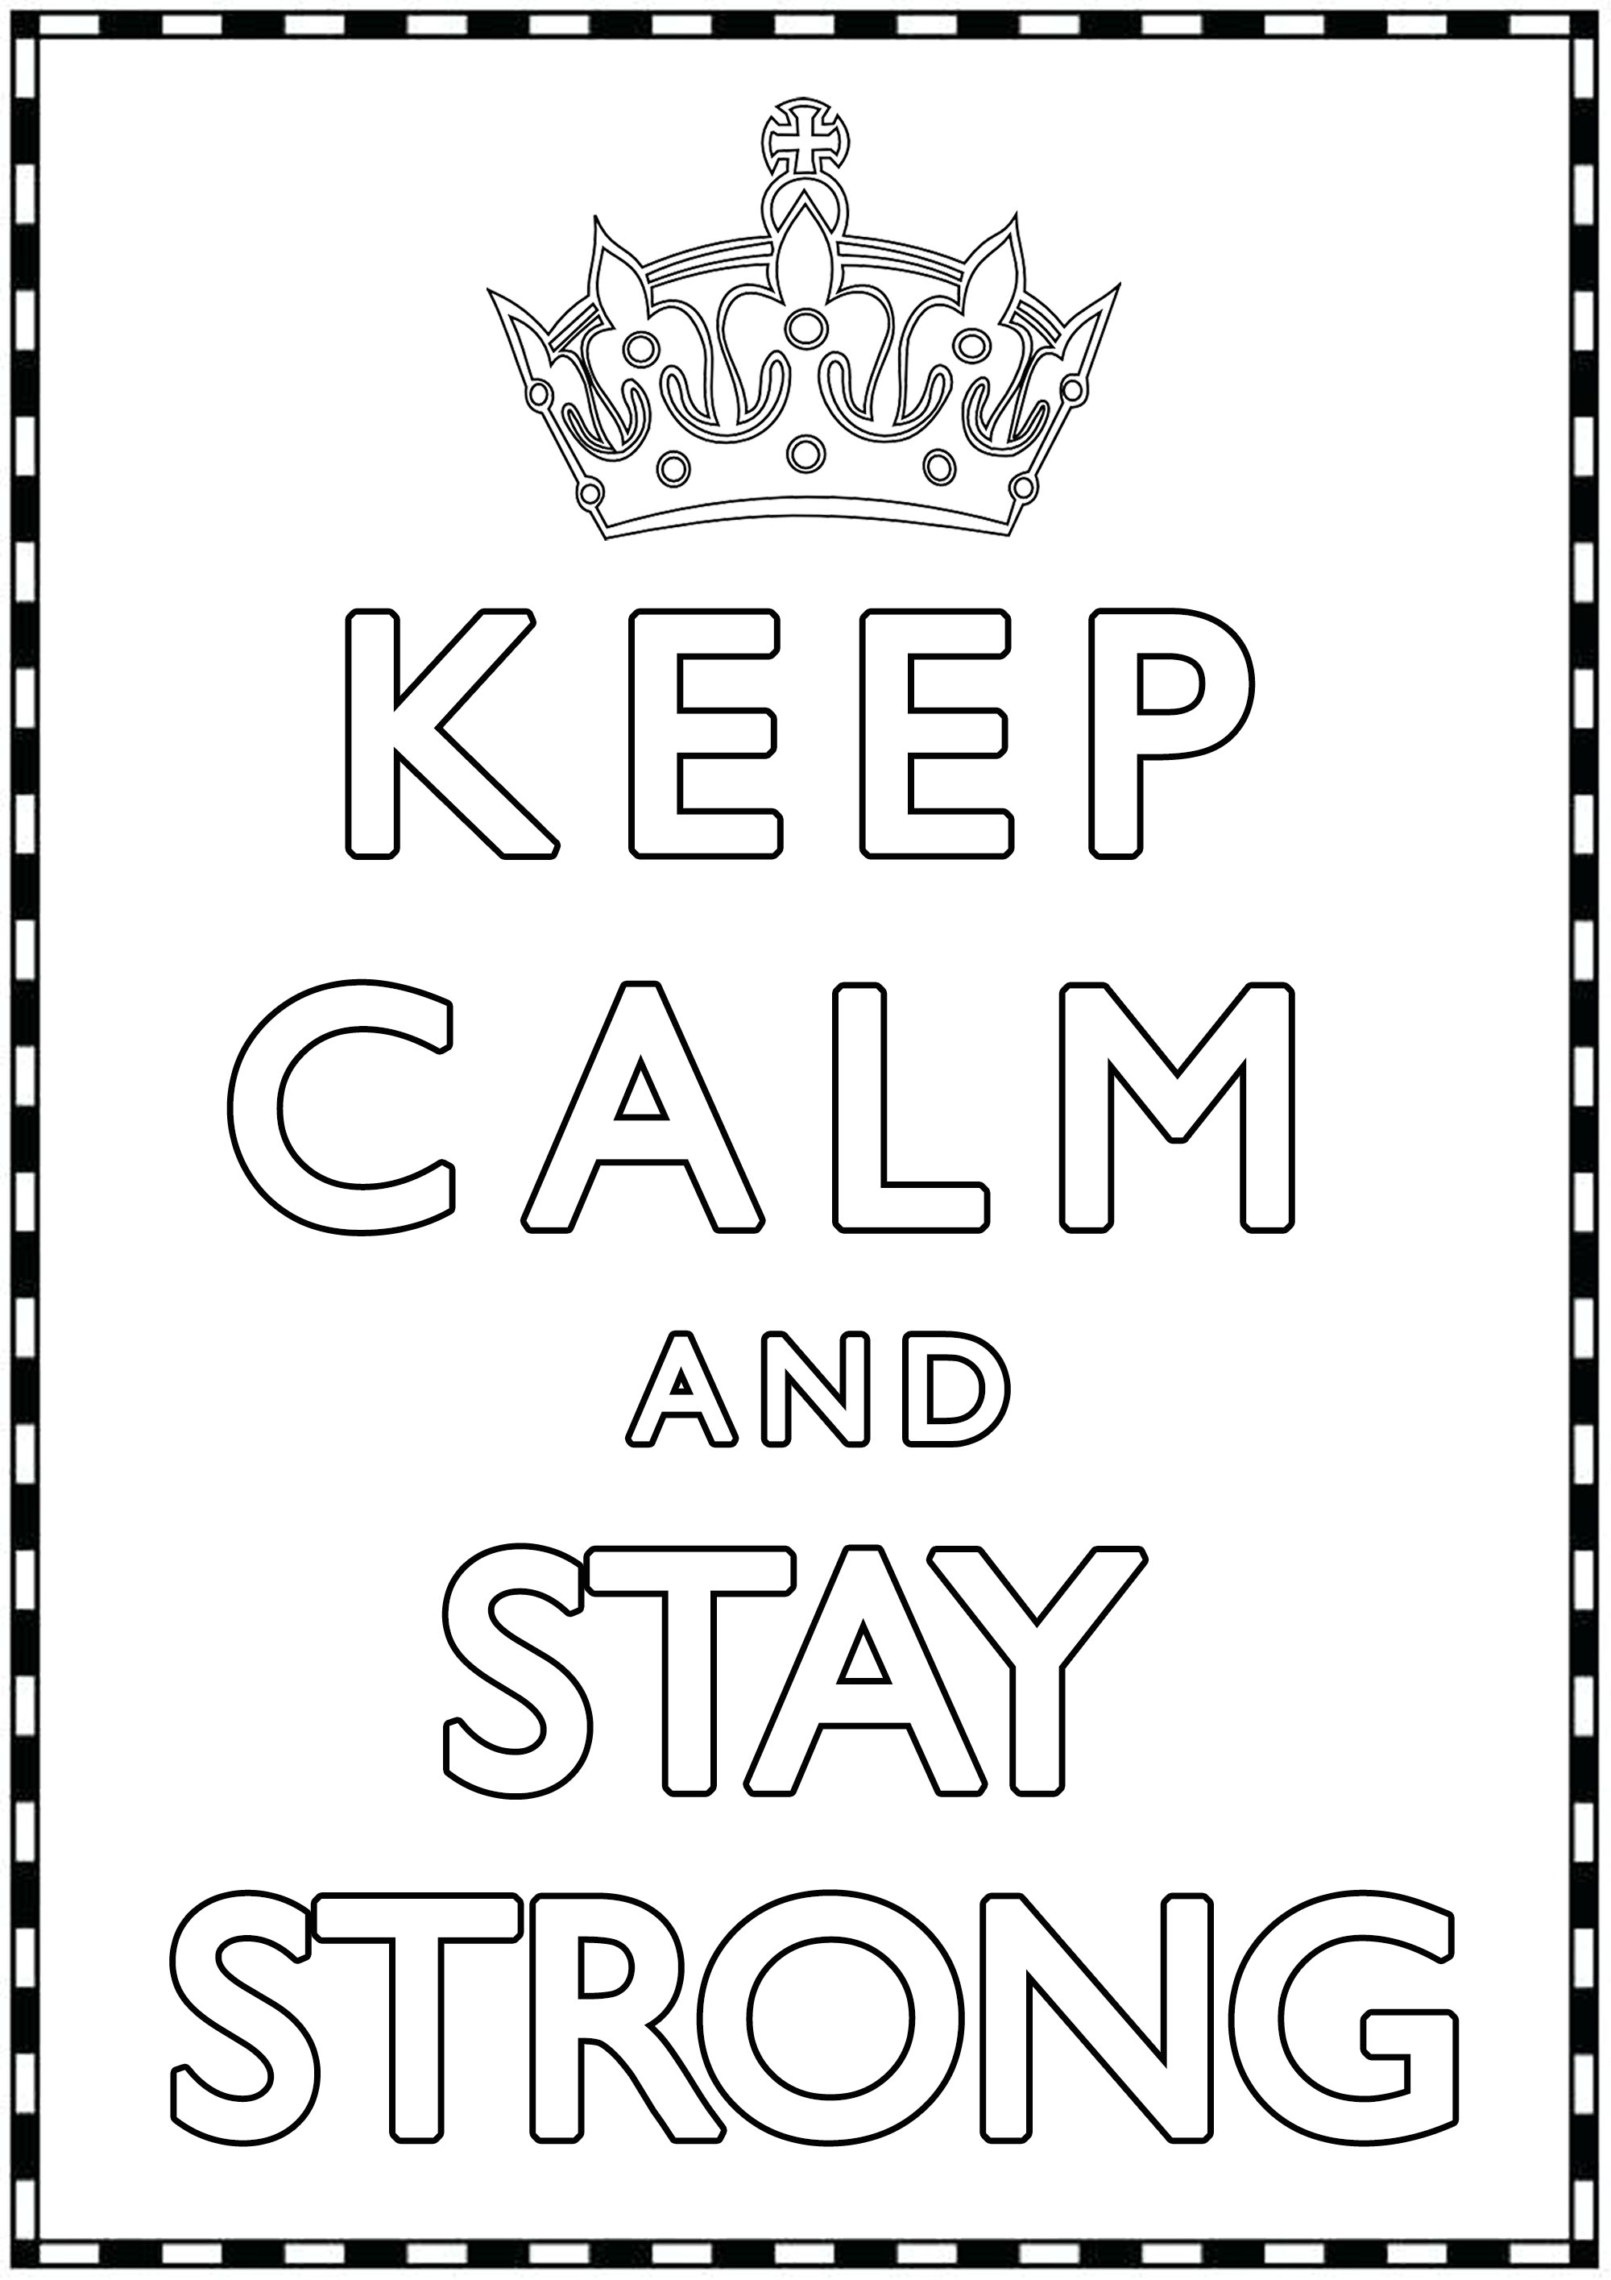

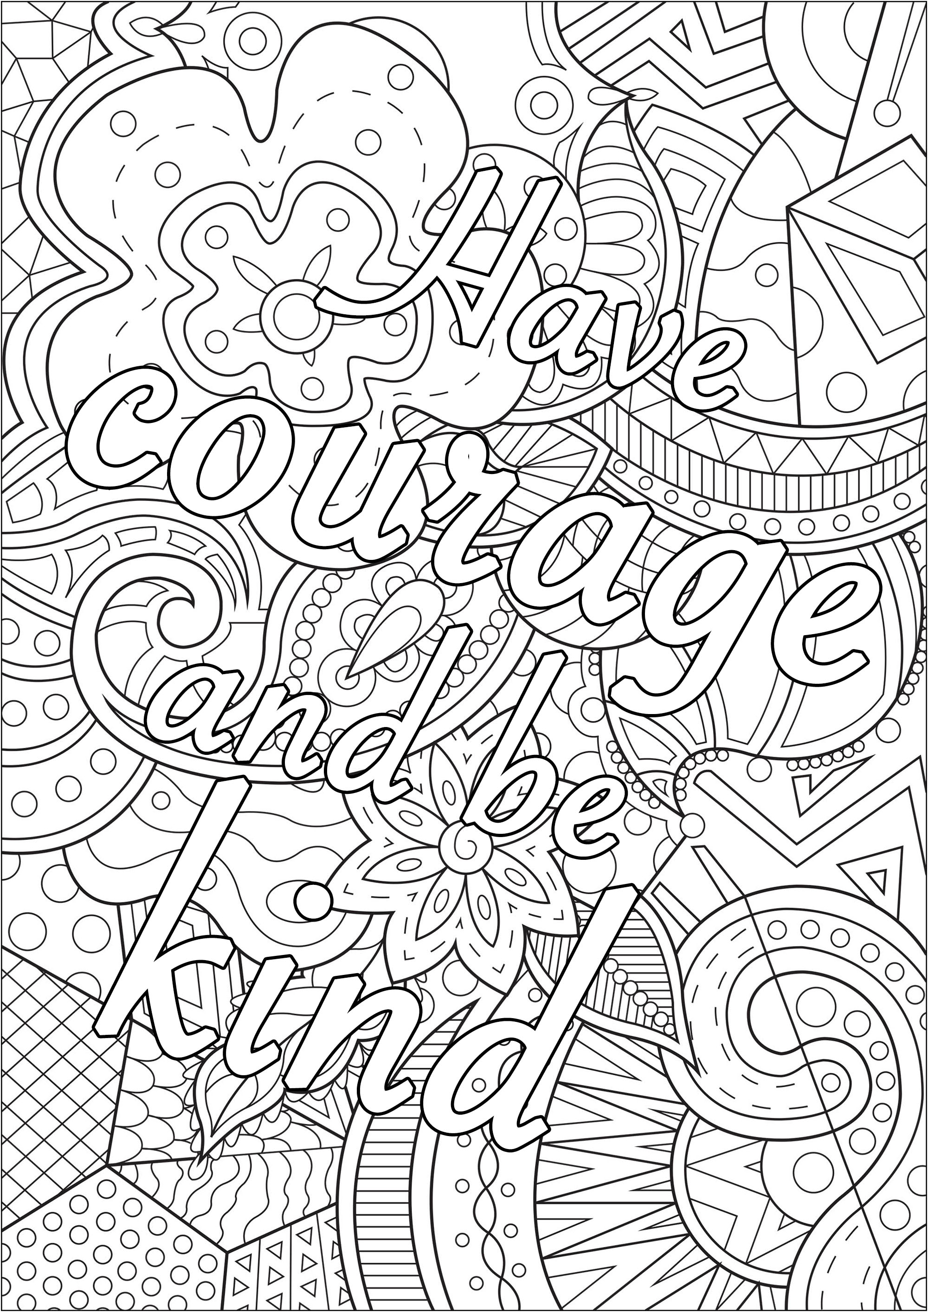****

****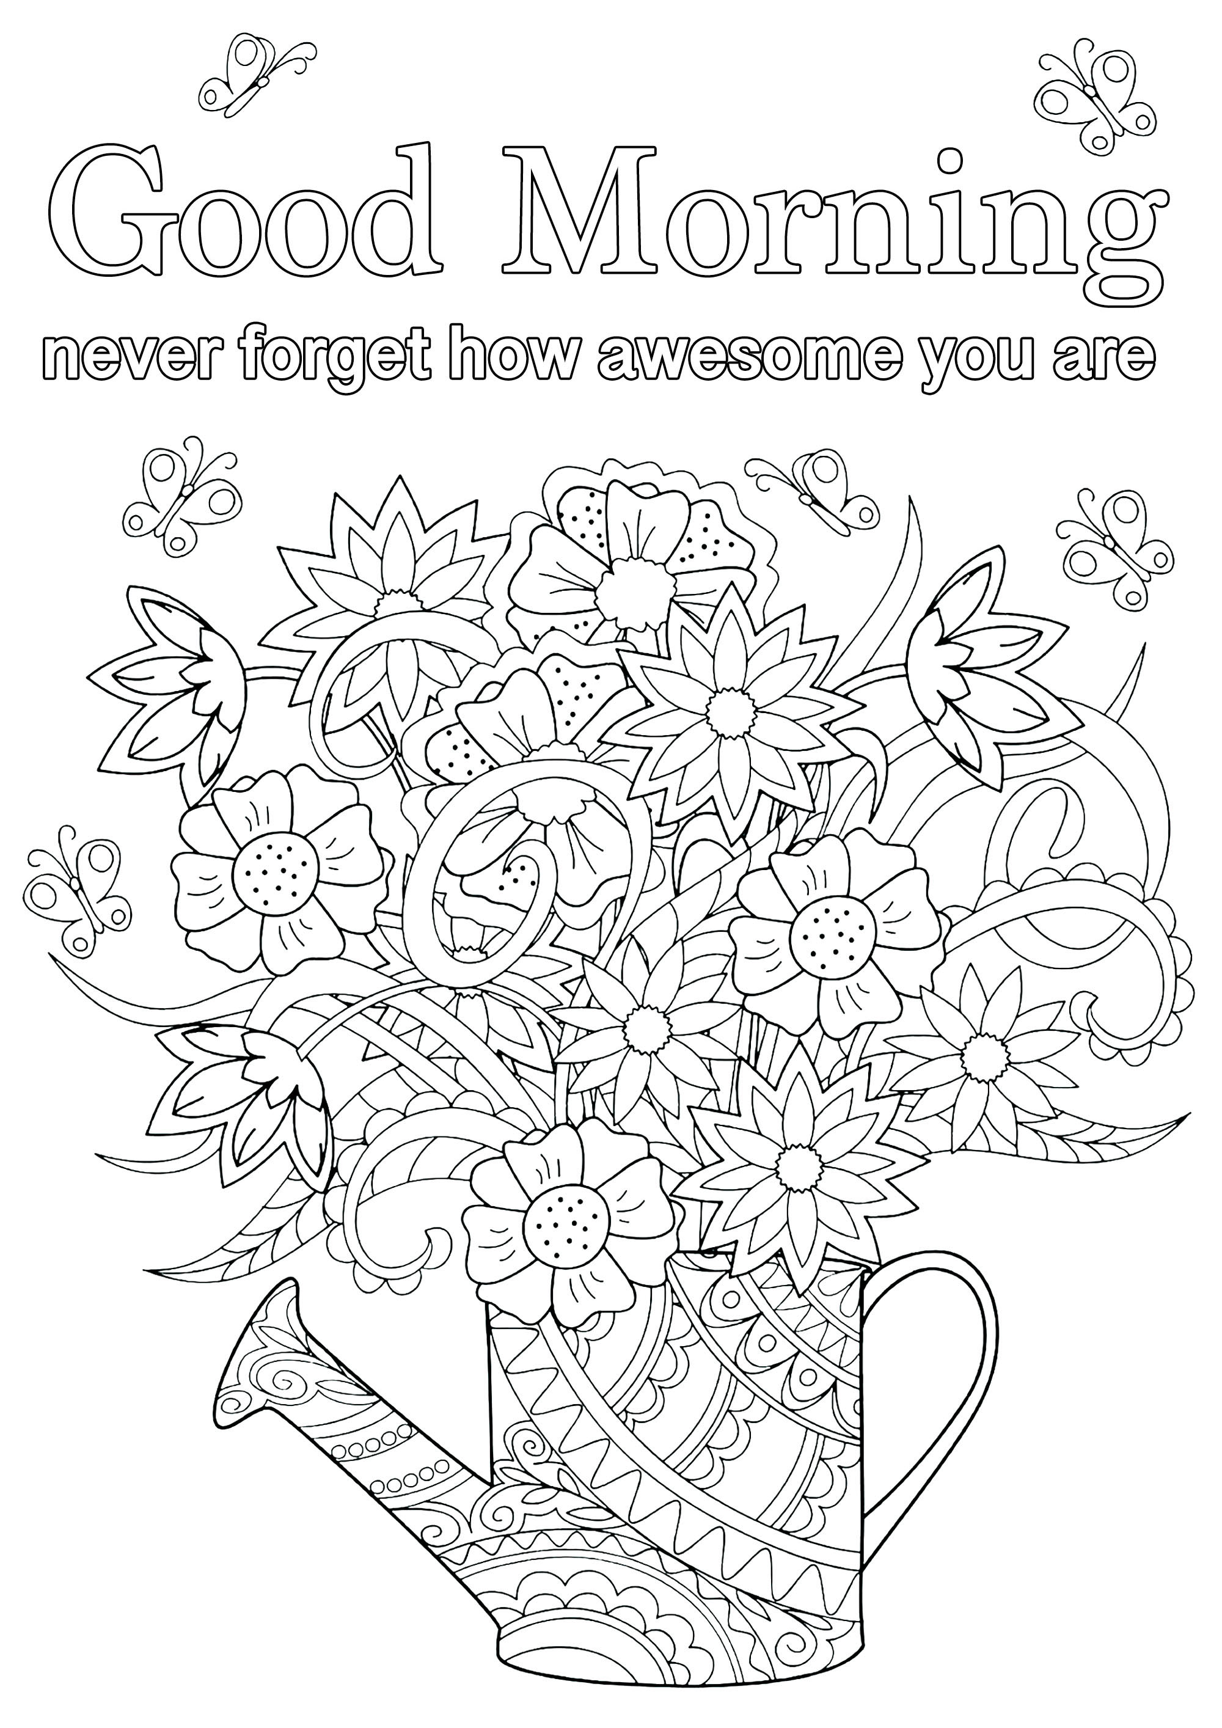



**How can I support my child?**

Young Minds have published great resources and ideas about things young people can do to manage any stress and anxiety they may experience in relation to coronavirus: <https://youngminds.org.uk/blog/what-to-do-if-you-re-anxious-about-coronavirus/>

They also have a mental health advice line available for parents operating between 09:30am-4pm, Monday- Friday: **0808 802 5544**

Centers for Disease Control and prevention provide some helpful messages on how to talk to children about Coronavirus: <https://www.cdc.gov/coronavirus/2019-ncov/daily-life-coping/talking-with-children.html?CDC_AA_refVal=https%3A%2F%2Fwww.cdc.gov%2Fcoronavirus%2F2019-ncov%2Fcommunity%2Fschools-childcare%2Ftalking-with-children.html>

The Anna Freud centre have also made a video for parents that can be found by clicking the following link: <https://www.youtube.com/watch?v=ZnANLAcpRZ4&feature=youtu.be>

**  
Helpful contact details**

As a team, we understand how unsettling this time can be for you. I have found various helplines/contact information of organisations that can offer support outside of our working hours

* Beat (Eating Disorder Charity) - 0808 801 0677 (online, webchat, telephone and email support)   
  <https://www.beateatingdisorders.org.uk/>
* Childline – 0800 1111 (online and telephone support)   
  <https://www.childline.org.uk>
* Kooth (online support)  
  <https://www.kooth.com/>
* SANE (a mental health charity) that offers advice and support (online only at present - [**support@sane.org.uk**](mailto:support@sane.org.uk)
* **The Anna Freud Centre have produced a video for young people:** <https://www.youtube.com/watch?v=ME5IZn4-BAk&feature=youtu.be>

**Motivational quotes**

**[](https://www.jackcanfield.com/blog/how-to-believe-in-yourself/)[](https://www.strongwithpurpose.com/quotes/honor-your-deepest-needs/)[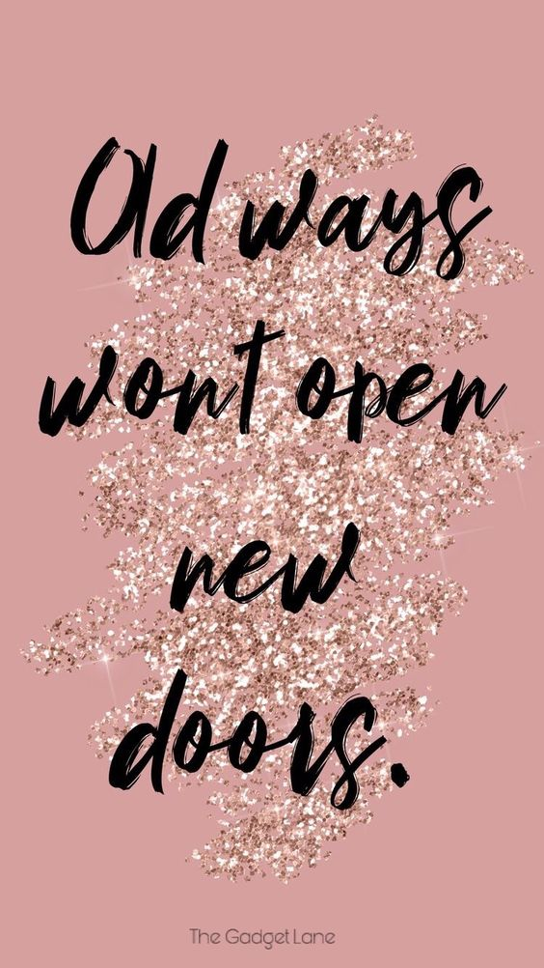](http://www.thegadgetlane.com/)[](http://kathleenquotesblog.whowhatwear.ru/436867-quotes-about-strength-in-hard-times-positivity-stay-strong-50-ideas.html)**

**[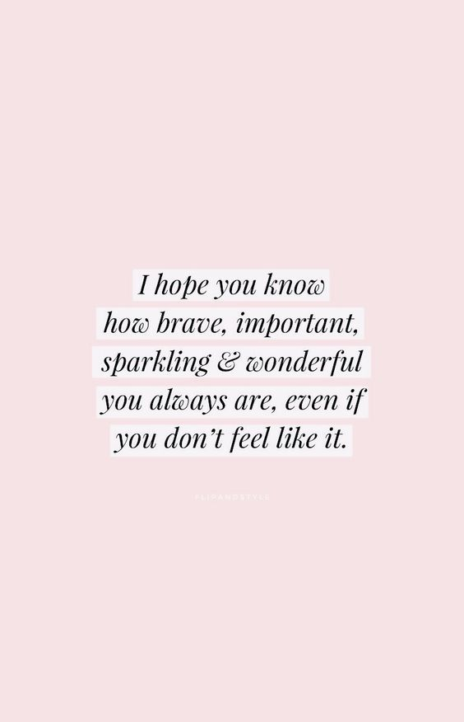](https://www.pinterest.com.au/pin/253679391496529577/)**

**[](https://functionalrustic.com/2019/06/10-inspirational-quotes-from-functional-rustic-6-4-19/)**

**[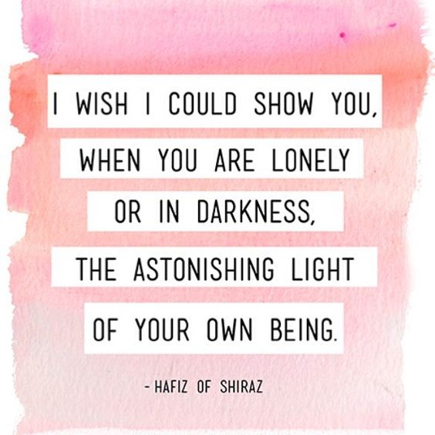](https://www.instagram.com/p/BCIUu1nSlMk/?taken-by=recovrywarriors)**

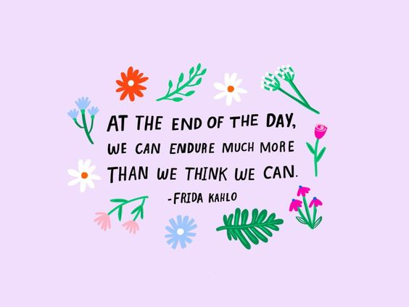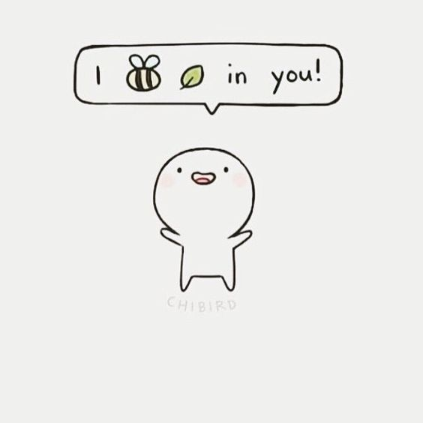



**Final thought**

I hope this information pack has been helpful. Please remember you aren’t on your own and in time, life will return to how you know it. We all understand how difficult it is for you and your families and we will stay in touch however we can. Your clinician will have been in contact with you and feel free to ask them any questions you have during your next “virtual contact.” On behalf of myself and the whole Hertfordshire CAMHS Eating Disorder Team, look forward to seeing you again in person whenever that time may be.

Best wishes,

Kerry O’Brien  
(CAMHS Eating Disorder Support Worker)

