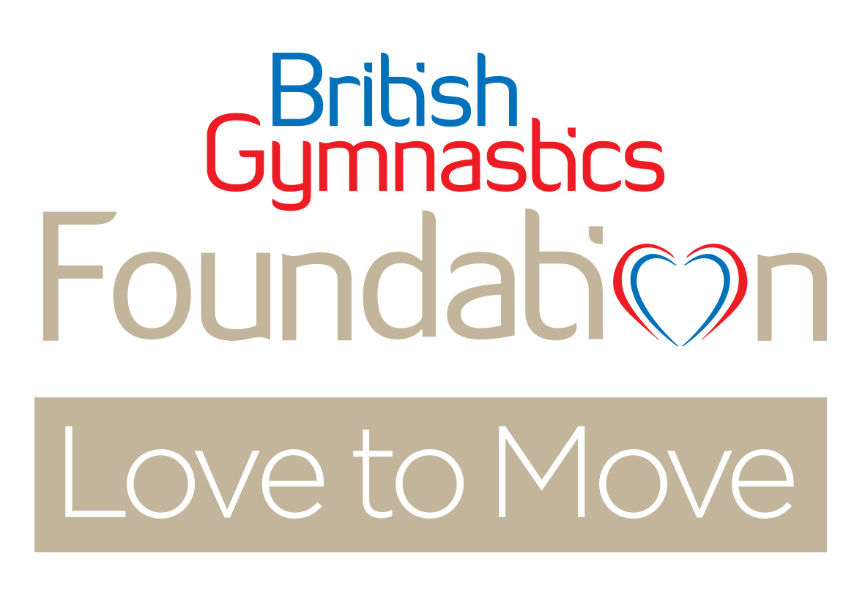
Love to Move Course
EXPRESSION OF INTEREST FORM

Love to Move is an age and dementia friendly seated exercise programme unlike any other. The programme has its roots taken from gymnastics and uses specially designed coordination and bilaterally asymmetrical movement patterns, which are thought to have the effect of increasing a person’s cognitive reserve.

Research on the programme to date has identified that Love to Move can make a significant impact on the quality of life for older people; and in particular, those living with dementia appear to benefit the most.

The Love to Move Course is currently in ‘pilot’ phase and consists of some pre-course reading and questions, 2 days of face to face learning with a Love to Move Tutor, some post-course shadowing/ mentoring/ co-delivery (depending on experience and competence shown on the course), and a final assessment in your own setting.

Once you have been successfully signed off at your assessment, you can apply for your Love to Move Licence to deliver. To maintain your Love to Move Licence, you will need to have a clean, current DBS (or Home country equivalent criminal records check), proof of valid public liability insurance, and a commitment to submit participation figures every 3-6 months via our online portal. For learners in England we also require deliverers to facilitate the collection of short demographic and active lifestyle surveys.

Course Cost:
The course cost is £300 per person which includes your assessment.
For more information on Love to Move or the content of the course please contact louise.roberts@britishgymnasticsfoundation.org

This form is an expression of interest form rather than an application form so please do not send any money with it.

Please fill out all details on this form and return to theteam@britishgymnasticsfoundation.org

The deadline for completed expression of interest forms for the
course in the Cambridgeshire area is
6th May 2019
Provisional dates of course July 2019

- Full Name

- Address

- Email address & mobile phone number
(NB: for course enrolment purposes we require your email address. In preparation for some of the course activities, we will need to send learners an audio file to their smart phones via the WhatsApp Application on your phone.)
Email:

Mobile Phone Number:

- Date of Birth (you must be over 18 yrs. to attend the course)

- Do you have a specific class/ Care Home or Community Centre where you hope to deliver Love to Move?
Yes ☐ No ☐
If yes, please state where this is; and any volunteer/ staff support you expect to have working with you to assist the class.

Amount you are contributing towards the course cost: | £
Grant/ Partnership funding | £
Total course cost: | £300

If you have put a cost against grant or partnership funding, please name the organisation the funding is coming from below:

Thank you for taking the time to complete this form.
Please return to: theteam@britishgymnasticsfoundation.org

