**Promoting positive mental health and wellbeing**

**Supporting Information**



**Bottisham Village College**

**Bottisham Village College**

**The policy document** is the outcome of a collaboration between Bottisham Village College and the CAMH Learning and Development team, Cambridgeshire and Peterborough NHS Foundation Trust.

It is intended as a template for other secondary schools and will therefore be made available across the county. Recommendations for adaptations for Primary Schools will be made available in due course.

However, it is not meant to be adopted without due process and careful and thorough consideration of the individual school’s needs in relation to the emotional wellbeing and mental health of its pupils and staff.

It is important that it embodies and reflects the school’s own culture since it will provide a window through which others will understand its ethos and approach in relation to these issues.





**Contents**

|  |  |
| --- | --- |
|  |  |
| **Section A:** Further information about mental health issues and sources of support | **3** |
| Prevalence of Mental Health and Emotional Wellbeing Issues | **3** |
| Thriving | **4** |
| Getting advice | **5** |
| Information about mental health issues | **7** |
| Self-harm | **7** |
| Depression | **8** |
| Anxiety, panic attacks and phobias | **8** |
| Obsessions and compulsions | **9** |
| Suicidal feelings | **9** |
| Eating problems | **10** |
| **Diagram 1 –** Thrive model | **11** |
| **Section B:** Guidance and advice documents | **12** |
| Local guidance documents | **16** |
| **Section C:** Data Sources | **18** |
| **Section D:** Sources of support in school and in the local community | **20** |
| Getting help | **20** |
| Getting more help | **23** |
| Getting risk support | **25** |
| Managing critical incidents | **26** |
| **Diagram 2 –** Getting help and getting more help: Assessment and intervention pathway | **27** |
| **Diagram 3 -** Process for clarifying the nature of the Suicide Risk to determine response | **28** |
| Glossary of terms | **29** |

# Section A: Further information about mental health issues and sources of support

“The education system has a front line role in children and young people’s mental health and well-being. Evidence to this inquiry suggested a growing prevalence of mental ill-health among children and young people, particularly for behavioural and emotional conditions such as anxiety, depression and conduct disorders.”

(Children and Young People’s Mental Health- the role of Education. First joint report of the Education and Health Committees of Session 2016-17. April 2017)

**Prevalence of Mental Health and Emotional Wellbeing Issues[1]**

1 in 10 children and young people aged 5 - 16 suffer from a diagnosable mental health disorder - that is around three children in every class. One in eight (12.8%) 5 to 19 year olds had at least one mental disorder when assessed in 2017

<https://digital.nhs.uk/data-and-information/publications/statistical/mental-health-of-children-and-young-people-in-england/2017/2017>

* Between 1 in every 12 and 1 in 15 children and young people deliberately self-harm
* There has been a big increase in the number of young people being admitted to hospital because of self-harm. Over the last ten years this figure has increased by 68%
* More than half of all adults with mental health problems were diagnosed in childhood. Less than half were treated appropriately at the time. 50% of people with life time mental health illness experience symptoms by age 14. 75% of people with lifetime mental health illness experience symptoms by age 24
* Nearly 80,000 children and young people suffer from severe depression
* The number of young people aged 15-16 with depression nearly doubled between the 1980s and the 2000s

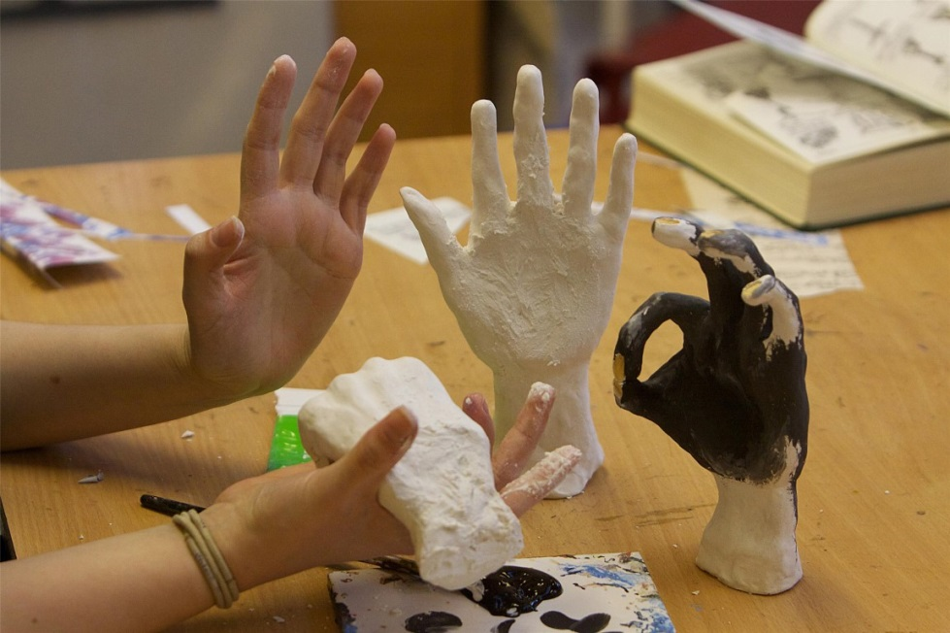

* Over 8,000 children aged under 10 years old suffer from severe depression
* 3.3% or about 290,000 children and young people have an anxiety disorder, (2.2% of 5-19 year olds, and 4.4% of 11-16 year olds)
* 72% of children in care have behavioural or emotional problems - these are some of the most vulnerable people in our society.

We have provided brief information about the issues most commonly seen in school-aged children. The links below and those attached to each topic will take you through to the most relevant page of the listed website. All the links for children and young people have been approved as safe and reliable.

**General support on all these issues can be accessed via**

* [Young Minds](http://www.youngminds.org.uk/for_parents/whats_worrying_you_about_your_child/self-harm) (www.youngminds.org.uk), [Mind](http://www.mind.org.uk/information-support/types-of-mental-health-problems/self-harm/#.VMxpXsbA67s) (www.mind.org.uk) and (for e-learning opportunities) [Minded](https://www.minded.org.uk/course/view.php?id=89) ([www.minded.org.uk](http://www.minded.org.uk)) and ( [www.minded.org.uk/families](http://www.minded.org.uk/families)) and ([www.wellinformed.org.uk](http://www.wellinformed.org.uk)) The place to go to for the children and young people’s workforce to get instant, accurate support on youth mental health
* The Royal College of Psychiatrists website provides factsheets about problems and disorders, links and a mental health app. <http://www.rcpsych.ac.uk/healthadvice/parentsandyouthinfo.aspx>
* Bailey S. and Shooter M., 2009, *The Young Mind*. London: Bantom Press
* *Young Minds in our Schools: a guide for teachers and others working in schools* . Youngminds

We have structured the information in this Appendix and also Appendix D to reflect the **new service** **model** for Child and Adolescent Mental Health Services (CAMHS), their partner organisations and County District teams. It is called **THRIVE**. (see attached diagram 1)

**“Thriving”**

Is supported by whole school approaches which promote emotional wellbeing and build resilience and life skills to cope with life’s challenges.

**Useful resources include:**

* The **Academic Resilience Approach** provides “ free, practical resources to help everyone in the school community step up and support pupils’ academic resilience.” <https://youngminds.org.uk/what-we-do/our-projects/academic-resilience>
* **Resilience and Results:** This documentwas produced to help schools understand the importance of supporting their pupils’ emotional wellbeing, what they can do within schools and how they can work in partnership with local agencies and commission additional support.

<http://www.cypmhc.org.uk/resources/resilience-and-results-how-improve-emotional-and-mental-wellbeing-children-and-young>

* **BoingBoing** An evidence based resilience framework for parents, practitioners and young people. [www.boingboing.org.uk](http://www.boingboing.org.uk)
* **The Charlie Waller Memorial** **Trust** provides free talks and training on mental health in schools and resources that are suitable for staff, pupils and parents. [www.cwmt.org.uk/freestuff](http://www.cwmt.org.uk/freestuff)
* **Supporting schools** in reviewing and developing policy and practice in a wide range of health related themes, including mental health and emotional wellbeing, drug education, sex and relationships education, anti-bullying, healthy lifestyles (including healthy eating), loss and change and citizenship <http://www5.cambridgeshire.gov.uk/learntogether/homepage/88/pshe/>
* **Mental Health Training** for Cambridgeshire Children’s workforce. <http://www.trainingcamh.net/>
* **The resilient classroom** <https://youngminds.org.uk/media/1463/the_resilient_classroom-2016.pdf>
* **UK Resilience Programme** <https://assets.publishing.service.gov.uk/government/uploads/system/uploads/attachment_data/file/197313/DFE-RB097.pdf>
* **Hands on Scotland** practical information, tools and activities to help children and young people to flourish <http://handsonscotland.co.uk/>
* **Mental Health Foundation** <https://www.mentalhealth.org.uk/podcasts-and-videos/podcasts-for-your-wellbeing>
* **Mentally Healthy Schools** <https://www.mentallyhealthyschools.org.uk/teaching-resources/lesson-plans-and-pshe-resources/>
* **Anna Freud Centre for Excellence** <https://www.annafreud.org/what-we-do/schools-in-mind/resources-for-schools/supporting-staff-wellbeing-in-schools/>
* **And Anna Freud expert videos** <https://security-eu.mimecast.com/ttpwp#/enrollment?key=2e282dda-79db-480f-86e7-419997202abd>

**“Getting advice”**

Is the first stage of intervention when a child, young person and/ or their family simply need directing towards safe and reliable advice and information that is available to everyone. (See Appendix D for “**Getting** **help**”, “**Getting more help**” and “**Getting Risk Support**”)

In the **school setting, “getting advice”** is on offer from:

* school nurse drop-ins, pastoral support workers, learning support teams, form tutors and peer support and includes signposting to services and resources offering self-help and self management advice.
* The Emotional Health and Wellbeing Service [ccs.ehw@nhs.net](mailto:ccs.ehw@nhs.net)

The team comprises nine Emotional health and Wellbeing Practitioners who can support schools in responding to children and young people who have EHW needs but who either do not meet thresholds for targeted or specialist interventions, or who are not yet ready to engage productively with them. This can include; signposting; advice and consultation; support with planning to make adjustments for their in-school experience that will contain distress and prevent deterioration, and assistance with reviewing these measures; support with referrals to the wider emotional health and wellbeing services available for children, young people and families. They work closely with the Early help Hubs and the CAMH Single Point of Access (SPA).

Contact via email or by phone, 9.30-16.30pm. 0300 55 50 60

The following list of websites and apps for young people includes those which are specific to Cambridgeshire and focuses on those which support emotional wellbeing and / or provide general information and advice about mental health.

* [www.keepyourhead.com](http://www.keepyourhead.com)The Keep Your Head website is a ‘one-stop shop’ for information on wellbeing and mental health for people of all ages across Cambridgeshire and Peterborough. The Keep Your Head website has dedicated areas providing information targeted at children and young people and at adults. The website covers a range of issues including stress, bullying, self-harm and what to do in a mental health crisis. There is also a range of resources and wellbeing information for teachers including PSHE materials and training opportunities
* [www.youthoria.org](http://www.youthoria.org) is a website for young people aged 11-19 in Cambridgeshire which has information about mental health
* [www.moodbug.me](http://www.moodbug.me) A tool for sharing how you feel with your close friends and letting them know when you are thinking about them
* [www.talktofrank.com/](http://www.talktofrank.com/) A national drug education service jointly established by the Department of Health
* [www.bullying.co.uk](http://www.bullying.co.uk) for advice about bullying
* [www.innovationlabs.org.uk](http://www.innovationlabs.org.uk) Includes 7 apps and websites to improve young people’s mental health
* [www.amazon.co.uk/Sitting-Still-Like-Frog-Mindfulness/dp/1611800587](http://www.amazon.co.uk/Sitting-Still-Like-Frog-Mindfulness/dp/1611800587) Simple mindfulness practices for children aged 5-12 to help deal with anxiety, improve concentration and handle difficult emotions
* <http://smilingmind.com.au/smiling-mind-app/> For adults, young people and children to help reduce worries, anxiety and distress
* [www.rethink.org](http://www.rethink.org) A mental health charity providing information and advice, including about local services
* <https://reading-well.org.uk/books/books-on-prescription/young-people-mental-health> The Shelf-help scheme provides recommended, expert endorsed books about mental health for 13-18 year olds through libraries. Collections are available through Cambridgeshire libraries
* [www.kooth.com](http://www.kooth.com/) A free on-line counselling and emotional wellbeing support service for children and young people
* <https://play.google.com/store/apps/details?id=com.bstro.MindShift> Mindshift: An App to help teens and young adults cope with anxiety
* <http://www.moodjuice.scot.nhs.uk>

Provides self-help guides on a range of mental health issues

* <https://www.meetwo.co.uk/> A new app for young people. They can post problems, share solutions, access expert help and educational resources. The app is 100% moderated and the directory links to a broad range of real world support groups. Suicidal posts are screened out, the posters are emailed directly and referred to Childline.
* [www.childline.org.uk](http://www.childline.org.uk) Information and advice on a range of topics. On line counselling service
* <https://epicfriends.co.uk/> Help for young people aged 12-18 to understand and support their friends through difficult times. Specialist content by Sheffield CAMHS

# Information about mental health issues

## Self-harm

Self-harm describes any behaviour where a young person causes harm to themselves in order to cope with thoughts, feelings or experiences they are not able to manage in any other way. It most frequently takes the form of cutting, burning or non-lethal overdoses in adolescents, while younger children and young people with special needs are more likely to pick or scratch at wounds, pull out their hair or bang or bruise themselves.

### Online support

* [www.SelfHarm.co.uk](https://www.selfharm.co.uk/) A project dedicated to supporting young people impacted by self harm, providing a safe space to talk, ask any questions and obtain help to overcome difficulties. It also provides information about how to stay safe
* [National Self-Harm Network](http://www.nshn.co.uk): [www.nshn.co.uk](http://www.nshn.co.uk/) provides crisis support, information and resources, advice, discussion and distractions and is available 24/7. Also supports and provides information for families and carers
* <https://youngminds.org.uk/what-we-do/our-projects/no-harm-done/> No Harm Done? Created in collaboration with the Charlie Waller memorial trust and the Royal College of Psychiatrists. For young people who are self harming or at risk of self harming, their parents and professionals working with them. Provides a series or resource publications and short films.
* <https://www.familylives.org.uk/advice/teenagers/health-wellbeing/self-harm/> Family Lives is a charity helping parents to deal with the changes that are a constant part of family life members .They provide professional, non-judgmental support and advice through a helpline, extensive advice on the website, befriending services, and parenting/relationship support groups. Nearly all of our services are accessible at no charge to parents 365 days a year



### Books

* Pooky Knightsmith (2015) Self-Harm and Eating Disorders in Schools: A Guide to Whole School Support and Practical Strategies. London: Jessica Kingsley Publishers
* Keith Hawton and Karen Rodham (2006) By Their Own Young Hand: Deliberate Self-harm and Suicidal Ideas in Adolescents. London: Jessica Kingsley Publishers
* Carol Fitzpatrick (2012) A Short Introduction to Understanding and Supporting Children and Young People Who Self-Harm. London: Jessica Kingsley Publishers
* Understanding and responding to children and young people at risk of self harm and suicide.(2014)CPFT <http://www.cpft.nhs.uk/U%20R%20CYP%20at%20risk%20of%20selfharm%20and%20suicide%202014%20v1%20electronic.pdf>

## 

## Depression

Ups and downs are a normal part of life for all of us, but for someone who is suffering from depression these ups and downs may be more extreme. Feelings of failure, hopelessness, numbness or sadness may invade their day-to-day life over an extended period of weeks or months, and have a significant impact on their behaviour and ability and motivation to engage in day-to-day activities.

### Online support

* [www.youngminds.org.uk](http://www.youngminds.org.uk) Information and advice. Parent’s helpline.
* [www.relate.org.uk](http://www.relate.org.uk) Counselling and on line information and support to families
* <https://www.cwmt.org.uk/> The Charlie Waller Memorial Trust seeks to equip young people to look after their mental wellbeing and to help people to recognise the signs of depression in themselves and others so that they know when to seek help.
* [www.inhand.org.uk](http://www.inhand.org.uk) A digital friend that provides young people with tools, advice and activities when their mental health is at risk
* [www.docready.org.uk](http://www.docready.org.uk) helps young people feel more confident and get better results when they see their GP about a mental health issue.
* [www.findgetgive.org.uk](http://www.findgetgive.org.uk) offers support for young people to find mental health support in their area and give feedback on it.
* [www.headsmed.org.uk](http://www.headsmed.org.uk) Accessible, straight talking information on young people’s mental health medication
* CHUMS <http://chums.uk.com/low-mood-and-feeling-sad/>
* CWMT <https://www.cwmt.org.uk/parents-guide>

**Books**

* Christopher Dowrick and Susan Martin (2015) *Can I Tell you about Depression?: A guide for friends, family and professionals*.London: Jessica Kingsley Publishers

## 

## Anxiety, panic attacks and phobias

Anxiety can take many forms in children and young people, and it is something that each of us experiences at low levels as part of normal life. When thoughts of anxiety, fear or panic are repeatedly present over several weeks or months and/or they are beginning to impact on a young person’s ability to access or enjoy day-to-day life, intervention is needed.

### 

### Online support

* [Anxiety UK](https://www.anxietyuk.org.uk): [www.anxietyuk.org.uk](http://www.anxietyuk.org.uk/) and [www.supportline.org.uk/problems/anxiety.ph](http://www.supportline.org.uk/problems/anxiety.ph) Advice, services and resources
* Headspace app: <https://www.headspace.com/headspace-meditation-app> and <https://www.headspace.com/kids> Themed sessions on meditation. For adults, children and young people
* Calm: <https://www.calm.com/> Meditation app to reduce anxiety and improve sleep
* CHUMS <http://chums.uk.com/anxiety>

### 

### Books

* Lucy Willetts and Polly Waite (2014) Can I Tell you about Anxiety?: A guide for friends, family and professionals. London: Jessica Kingsley Publishers
* Carol Fitzpatrick (2015) A Short Introduction to Helping Young People Manage Anxiety. London: Jessica Kingsley Publishers

## 

## Obsessions and compulsions

Obsessions describe intrusive thoughts or feelings that enter our minds which are disturbing or upsetting; compulsions are the behaviours we carry out in order to manage those thoughts or feelings. For example, a young person may be constantly worried that their house will burn down if they don’t turn off all switches before leaving the house. They may respond to these thoughts by repeatedly checking switches, perhaps returning home several times to do so. Obsessive compulsive disorder (OCD) can take many forms – it is not just about cleaning and checking.

**Online support**

* OCD UK [www.ocduk.org/ocd](http://www.ocduk.org/ocd) Advice line, Advocacy, publications, treatment information and support groups

### 

### Books

* Amita Jassi and Sarah Hull (2013) Can I Tell you about OCD?: A guide for friends, family and professionals. London: Jessica Kingsley Publishers
* Susan Conners (2011) The Tourette Syndrome & OCD Checklist: A practical reference for parents and teachers. San Francisco: Jossey-Bass

## 

## Suicidal feelings

Young people may experience complicated thoughts and feelings about wanting to end their own lives. Some young people never act on these feelings though they may openly discuss and explore them, while other young people die suddenly from suicide apparently out of the blue.

**See Section D and Risk flowchart for guidance on responding to risk and getting support**

### Online support

* [Prevention of young suicide UK – PAPYRUS](https://www.papyrus-uk.org): [www.papyrus-uk.org](http://www.papyrus-uk.org) Provides confidential help and advise to young people and anyone worried about a young person. Helpline, email and texts to
* HOPELineUK. Help for professional and bereavement support. <https://www.papyrus-uk.org/help-advice/about-hopelineuk>
* [www.samaritans.org](http://www.samaritans.org) Helpline open every day 24/7
* On the edge: ChildLine spotlight report on suicide: [www.nspcc.org.uk/perventing-abuse/research-and-resources/on-the-edge-childline-spotlight](http://www.nspcc.org.uk/perventing-abuse/research-and-resources/on-the-edge-childline-spotlight)
* STOP Suicide is an award-winning suicide prevention campaign that seeks to empower communities and individuals across Cambridgeshire and Peterborough to help stop suicides by being alert to the warning signs, asking directly about suicide and helping those who are feeling suicidal to stay safe <http://www.stopsuicidepledge.org/>

### Books

* Keith Hawton and Karen Rodham (2006) *By Their Own Young Hand: Deliberate Self-harm and Suicidal Ideas in Adolescents*.London: Jessica Kingsley Publishers
* Terri A.Erbacher, Jonathan B. Singer and Scott Poland (2015) *Suicide in Schools: A Practitioner’s*
* *Guide to Multi-level Prevention, Assessment, Intervention, and Postvention*. New York: Routledge

## Eating problems

Food, weight and shape may be used as a way of coping with, or communicating about, difficult thoughts, feelings and behaviours that a young person experiences day to day. Some young people develop eating disorders such as anorexia (where food intake is restricted), binge eating disorder and bulimia nervosa (a cycle of bingeing and purging). Other young people, particularly those of primary or preschool age, may develop problematic behaviours around food including refusing to eat in certain situations or with certain people. This can be a way of communicating messages the child does not have the words to convey.

### Online support

* [Beat – the eating disorders charity](http://www.b-eat.co.uk/get-help/about-eating-disorders/): [www.b-eat.co.uk/about-eating-disorders](http://www.b-eat.co.uk/about-eating-disorders) Year round, 24/7 helpline, HNS accredited information, message boards, support groups, helpfinder.
* [Eating Difficulties in Younger Children and when to worry](http://www.inourhands.com/eating-difficulties-in-younger-children/): [www.inourhands.com/eating-difficulties-in-younger-children](http://www.inourhands.com/eating-difficulties-in-younger-children) Presentation and links to resources

### 

### Books

* Bryan Lask and Lucy Watson (2014) Can I tell you about Eating Disorders?: A Guide for Friends, Family and Professionals. London: Jessica Kingsley Publishers
* Pooky Knightsmith (2015) Self-Harm and Eating Disorders in Schools: A Guide to Whole School Support and Practical Strategies. London: Jessica Kingsley Publishers
* Pooky Knightsmith (2012) Eating Disorders Pocketbook. Teachers’ Pocketbooks

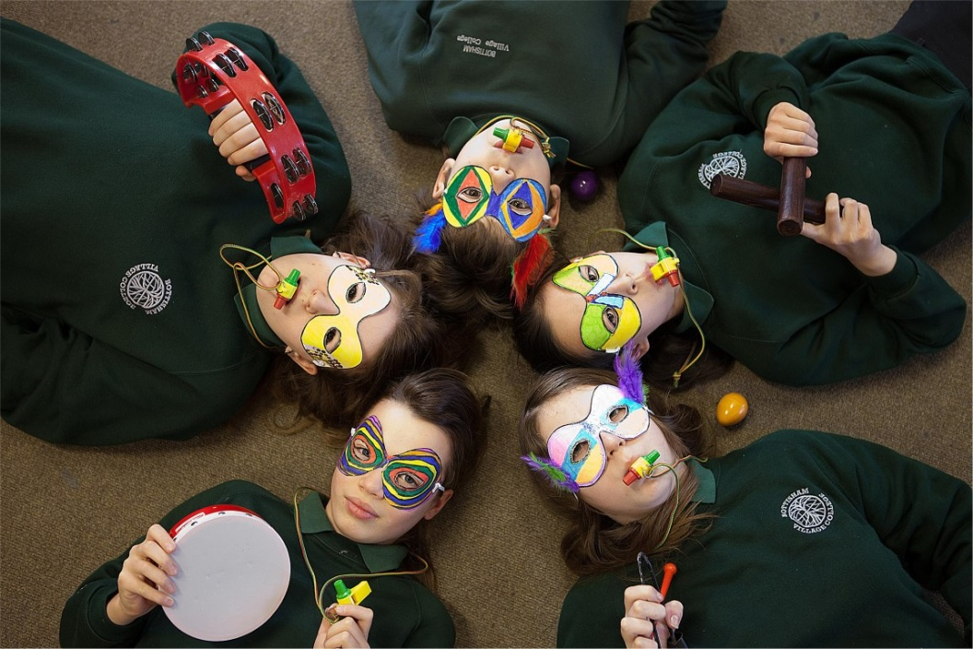

***\*Please note*** that in the Getting Advice Service grouping, the CPN project for schools and the HYPA clinics are in Peterborough only

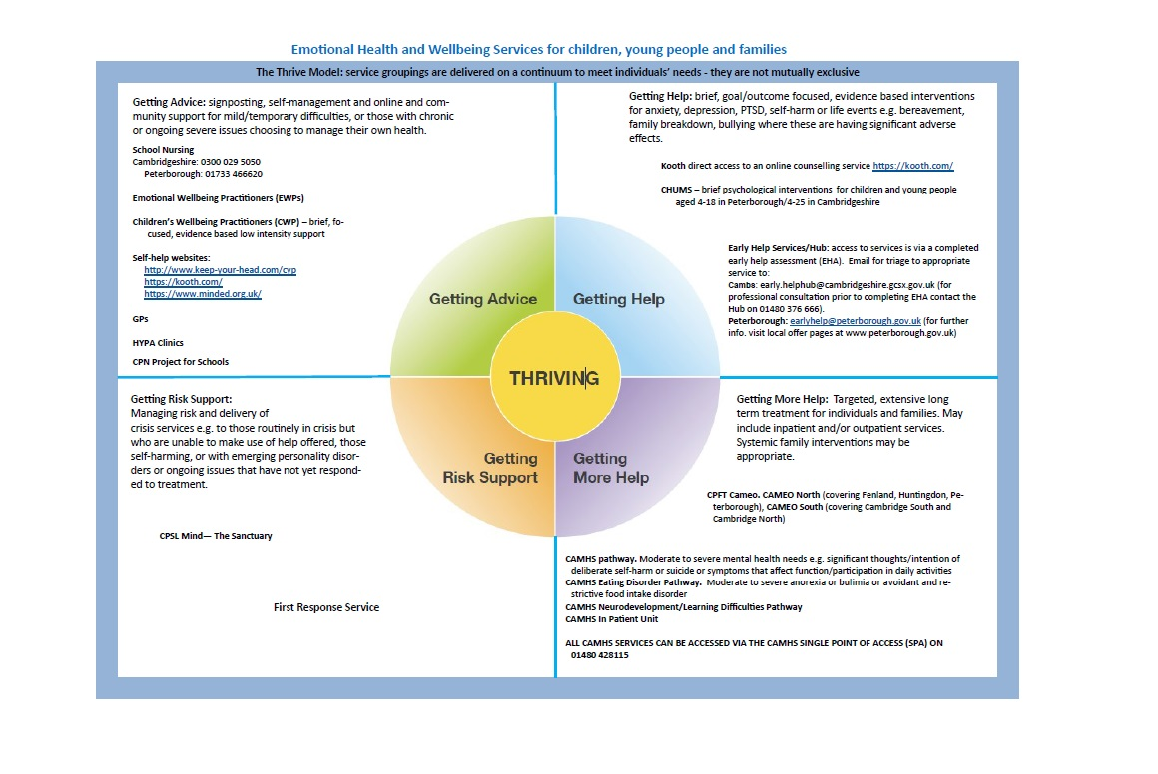

**Diagram 1**

# Section B: Guidance and advice documents

It is important to keep up to date with new guidance and policy changes and we recommend using the Keep Your Head website for current information.

**Mental Health and Behaviour in Schools. Department for Education (Nov 2018)** <https://www.gov.uk/government/publications/mental-health-and-behaviour-in-schools--2>

The DfE have updated existing guidance on [mental health and behaviour in schools](https://assets.publishing.service.gov.uk/government/uploads/system/uploads/attachment_data/file/755135/Mental_health_and_behaviour_in_schools__.pdf) with information about school responsibilities and how to identify behaviours that may be related to a mental health problem. The updated guidance also provides information on working with other professionals and external agencies, and where to find extra support

**Public Health England**: The link between Pupil Health and Wellbeing and Attainment. A Briefing for head teachers, governors and staff in education settings. (2014)

<https://www.gov.uk/government/publications/the-link-between-pupil-health-and-wellbeing-and-attainment>

**Public Health England:** Improving Young People’s health and wellbeing. A Framework for public health (2015)

A framework for national and local action to address the specific health needs of young people and ensure their future health.

<https://www.gov.uk/government/publications/improving-young-peoples-health-and-wellbeing-a-framework-for-public-health>

**Supporting mental health in schools and colleges. Quantitative survey** Department for education. (Aug 2017) Updated May 2018

Survey and case studies with schools on activities to support pupils’ mental health and wellbeing. <https://www.gov.uk/government/publications/supporting-mental-health-in-schools-and-colleges>

[**Counselling in schools: a blueprint for the future**](https://www.gov.uk/government/uploads/system/uploads/attachment_data/file/416326/Counselling_in_schools_-240315.pdf) **- departmental advice for school staff and counsellors.** Department for Education (2015) Updated Feb 2016

This is for:

* school leaders
* headteachers
* governing bodies
* those with day-to-day responsibility for mental health issues in schools such as:
* counsellors
* clinical supervisors
* managers of school counselling services
* It will also be of interest to NHS providers and local authority commissioners of counselling and other forms of psychological support.
* It applies to all primary and secondary schools.
* It is about providing counselling as a psychological therapy to improve the mental health and wellbeing of children and young people in schools

<https://www.gov.uk/government/publications/counselling-in-schools#history>

[**Teacher Guidance: Preparing to teach about mental health and emotional wellbeing**](http://www.inourhands.com/wp-content/uploads/2015/03/Preparing-to-teach-about-mental-health-and-emotional-wellbeing-PSHE-Association-March-2015-FINAL.pdf) PSHE Guided funded by the Dept of Education

<https://www.pshe-association.org.uk/curriculum-and-resources/resources/guidance-preparing-teach-about-mental-health-and>

The guidance has been fully updated and relaunched in March 2019 to match the government’s new statutory PSHE requirements regarding Health Education, Relationships Education and RSE

https://www.pshe-[association.org.uk/sites/default/files/Mental%20health%20guidance_0.pdf](https://www.pshe-association.org.uk/sites/default/files/Mental%20health%20guidance_0.pdf)

**Transforming children and young people’s mental health provision: a green paper** Dept of Health and Dept for Education. Dec 2017

<https://www.gov.uk/government/consultations/transforming-children-and-young-peoples-mental-health-provision-a-green-paper>

[**Keeping children safe in education**](http://www.gov.uk/government/uploads/system/uploads/attachment_data/file/372753/Keeping%20_children_safe_in_education.pdf) **- statutory guidance for schools and colleges** Department of Education (2016) Updated 2019

Statutory guidance for schools and colleges on safeguarding children and safer recruitment

<https://www.gov.uk/government/publications/keeping-children-safe-in-education--2>

**Working Together to Safeguard Children - July 2018 A Guide to interagency working**

<https://assets.publishing.service.gov.uk/government/uploads/system/uploads/attachment_data/file/729914/Working_Together_to_Safeguard_Children-2018.pdf>

[**Supporting pupils at school with medical conditions**](http://www.gov.uk/government/uploads/system/uploads/attachment_data/file/349435/Statutor%20y_guidance_on_supporting_pupils_at_school_with_medical_conditions.pdf) **- statutory guidance for governing bodies of maintained schools and proprietors of academies in England.** Department for Education (2014) Updated August 2017 Statutory guidance about the support that pupils with medical conditions should receive at school

<https://www.gov.uk/government/publications/supporting-pupils-at-school-with-medical-conditions--3>

**Special educational needs and disability (SEND)** Department of Education and Department of Health (2014) Statutory guidance for organisations which work with and support children and young people who have special educational needs or disabilities

<https://www.gov.uk/government/publications/send-code-of-practice-0-to-25>

[**Future in mind – promoting, protecting and improving our children and young people’s mental health and wellbeing**](https://www.gov.uk/government/uploads/system/uploads/attachment_data/file/414024/Childrens_Mental_Health.pdf)**.** A report produced by the Children and Young People’s Mental Health and Wellbeing Taskforce to examine how to improve mental health services for children and young people. Department of Health (2015)

<https://www.ncb.org.uk/sites/default/files/field/attachment/Future%20in%20Mind_Briefing.pdf>

**The National Institute for Health and Clinical Excellence (NICE) have produced two guidance documents for schools in relation to promoting social and emotional wellbeing**

**[NICE guidance on social and emotional wellbeing in secondary education](http://www.nice.org.uk/guidance/ph20)** [(2009)](http://www.nice.org.uk/guidance/ph20)

<https://www.nice.org.uk/guidance/ph20>

This guideline covers interventions to support social and emotional wellbeing among young people aged 11–19 years who are in full-time education

**NICE guidance on social and emotional wellbeing in primary education** (2008)

<https://www.nice.org.uk/guidance/ph12>

This briefing summarises NICE's recommendations for local authorities and partner children aged under 5 years and all children in primary and secondary education

Revised guidance will be published in May 2021. In the meantime the NICE pathways are regularly updated and can be viewed here <http://pathways.nice.org.uk/pathways/social-and-emotional-wellbeing-for-childrenand-young-people> NICE Pathway last updated: 24 May 2019 NICE Pathways bring together everything NICE says on a topic in an interactive flowchart. They are interactive and designed to be used online

***What works in promoting social and emotional wellbeing and responding to mental health problems in schools?* National Children’s Bureau (2016) A Whole school framework for emotional well-being and mental health.’**

This advice covers two overlapping areas of school practice: promoting positive social and emotional wellbeing for all in schools, and tackling the mental health problems of pupils in more serious difficulty

<https://www.ncb.org.uk/sites/default/files/uploads/documents/Health_wellbeing_docs/ncb_framework_for_promoting_well-being_and_responding_to_mental_health_in_schools.pdf>

**A whole school framework for emotional well-being and mental health. Supporting resources for school leaders.** National Children’s Bureau (2015)

It is intended to support all schools to create sustainable and manageable responses to the emotional wellbeing and mental health needs of both students and staff

<https://www.ncb.org.uk/sites/default/files/field/attachment/NCB%20School%20Well%20Being%20Framework%20Leaders%20Resources%20FINAL.pdf>

**What works in enhancing social and emotional skills development during childhood and adolescence?: A review of the evidence on the effectiveness of school-based and out-of-school programmes in the UK** Clarke et al 2015

**A review of the evidence on the effectiveness of school-based and out-of-school programmes in the UK**

[https://www.gov.uk/government/uploads/system/uploads/attachment_data/file/411492/What_works_in_enhancing_social_and_emotional_skills_development_during_childhood_and_adolescence.pdf](https://www.gov.uk/government/uploads/system/uploads/attachment_data/file/411492/What_works_in_enhancing_social_and_emotional_skills_development_during_childhood_and_adolescence.pdf%20)

**Improving the mental health of children and young people in England.** PHE (2016)

Reports to support commissioners in improving the mental health and wellbeing of children and young people

<https://www.gov.uk/government/publications/improving-the-mental-health-of-children-and-young-people>

**The Mental Health of Children and young people in England** PHE (2016)

The purpose of this report is to:

* Describe the importance of mental health in CYP
* Describe the case for investing in mental health
* Provide a descriptive analysis of mental health in CYP in England
* Summarise the evidence of what works to improve mental health in CYP in order to inform local transformation of services

<https://www.gov.uk/government/uploads/system/uploads/attachment_data/file/575632/Mental_health_of_children_in_England.pdf>

**Promoting children and young people’s emotional health and wellbeing: A whole school and college approach** PHE (2015)

Guidance for headteachers and college principals on the 8 principles for promoting emotional health and wellbeing in schools and colleges.

<https://www.gov.uk/government/publications/promoting-children-and-young-peoples-emotional-health-and-wellbeing>

[**Relationships Education, Relationships and Sex Education (RSE) and Health Education**](https://www.gov.uk/government/publications/relationships-education-relationships-and-sex-education-rse-and-health-education) new curriculum. From 2020, the following subjects will become compulsory in applicable schools in England.

* Relationship education in primary schools
* Relationship and sex education in secondary schools
* Health education in state funded primary and secondary schools

These subjects will support all young people to be happy, healthy and safe. Equipping them for life as an adult in British society.

https://www.gov.uk/government/publications/changes-to-personal-social-health-and-economic-pshe-and-relationships-and-sex-education-rse

**Children and young people's mental health —the role of education**

This inquiry follows two recent reports on children and young people’s mental health by the Health and Education Committees. Last year the Education Committee reported on the Mental health and well-being of looked-after children and in 2014, the then Health Committee published a report on Children’s and adolescents’ mental health and CAMHS

<https://publications.parliament.uk/pa/cm201617/cmselect/cmhealth/849/849.pdf>

Published on 2 May 2017 by authority of the House of Commons. House of Commons Education and Health committees

**What works in enhancing social and emotional skills development during childhood and adolescence?** A review of the evidence on the effectiveness of school-based and out-of-school programmes in the UK. Clarke et al 2015

[https://www.gov.uk/government/uploads/system/uploads/attachment_data/file/411492/What_works_in_enhancing_social_and_emotional_skills_development_during_childhood_and_adolescence.pdf](https://www.gov.uk/government/uploads/system/uploads/attachment_data/file/411492/What_works_in_enhancing_social_and_emotional_skills_development_during_childhood_and_adolescence.pdf%20%20)

**Education, Education, Education, Mental Health. Supporting secondary schools to play a central role in early intervention** IPPR (2015)

Supporting secondary schools to play a central role in early intervention mental health services

<https://www.ippr.org/files/publications/pdf/education-education-mental-health_May2016.pdf?noredirect=1>

**Children’s voices: A review of evidence on the subjective wellbeing of children with mental health needs in England** Children’s Commissioner Oct 2017.

It sets out the views, perspectives and experiences of children with mental health needs and gives anonymous first-hand accounts of children in England aged 17 and under who have dealt with mental health illnesses, shining a light on their experiences of support – or lack of it.

<https://www.childrenscommissioner.gov.uk/2017/10/10/shining-a-light-on-the-experiences-of-children-with-mental-health-nee>ds

**Briefing: Children’s mental healthcare in England** Children’s Commissioner Oct 2017.

Sets out the “shockingly poor” support children with mental health services are receiving from the NHS.

<https://www.childrenscommissioner.gov.uk/publication/briefing-childrens-mental-healthcare-in-england/>

**Early access to mental health support.** April 2019

This report illustrates the findings of a data collection exercise to understand spending on low-level mental health services across England

<https://www.childrenscommissioner.gov.uk/publication/early-access-to-mental-health-support/>

**Local Guidance documents**

**Cambridge and Peterborough Foundation Trust Services for children and young people**

<https://www.cpft.nhs.uk/training/childrens-services-welcome>

**Children and young people’s health services**

<http://www.cambscommunityservices.nhs.uk/what-we-do/children-young-people-health-services-cambridgeshire>

**J****oint Cambridgeshire and Peterborough Suicide Prevention Strategy 2017-2020**

<https://cambridgeshireinsight.org.uk/wp-content/uploads/2019/04/Suicide-prevention-strategy-2017-2020-v8.pdf>

**Advice and guidance on information sharing** can be found at <https://www.cambridgeshire.gov.uk/data-protection-and-foi/information-and-data-sharing/sharing-information-on-children-and-young-people/>

**Cambridgeshire Public Mental Health Strategy** (2015-2018) [f](http://democracy.cambridge.gov.uk/documents/s30639/Summary%20Public%20Mental%20Health%20Strategy.pdf) <https://democracy.cambridge.gov.uk/documents/s30639/Summary%20Public%20Mental%20Health%20Strategy.pdf>

**Cambridgeshire PSHE Service** provides a range of resources to support whole school approaches to mental health. https://www.cambslearntogether.co.uk/

**Cambridgeshire and Peterborough Local Transformation Plan for children’s and young people’s emotional/mental health and wellbeing** Refreshed 2018/2019

<https://www.cambridgeshireandpeterboroughccg.nhs.uk/your-health-and-services/children-and-young-people/>

**Assessment toolkit**

<http://www.keep-your-head.com/assets/1/cp_assessment_toolkit_pdf.pdf>

**Cambridgeshire LSCB Threshold Document** 2017 for descriptions of indicators of need and correlation with mental health needs. <http://www.safeguardingpeterborough.org.uk/children-board/professionals/procedures/threshold-document/>

**Integrated Front Door** (Safeguarding and early help)<https://www.cambridgeshire.gov.uk/residents/working-together-children-families-and-adults/how-we-work/children-and-families-services/integrated-front-door-safeguarding-and-early-help/>

Email: Early.helphub@cambridgeshire.gcsx.gov.uk

(Early Help Assessment information) <https://www.cambridgeshire.gov.uk/residents/children-and-families/parenting-and-family-support/providing-children-and-family-services-how-we-work>

**Social Care/Think family**

<https://www.cambridgeshire.gov.uk/residents/working-together-children-families-and-adults/how-we-work/children-and-families-services/children-and-families-procedures-and-resources/think-family/>

**The Thrive model** see [www.keepyourhead.com](http://www.keepyourhead.com) for local implementation and

<http://implementingthrive.org/implementation-sites/i-thrive-accelerator-sites/accelerator-site-2/> and for an overview;

<https://www.annafreud.org/media/9254/thrive-framework-for-system-change-2019.pdf>

**Cambridgeshire Children's Services Procedures.**

<https://www.cambridgeshire.gov.uk/residents/children-and-families/parenting-and-family-support/providing-children-and-family-services-how-we-work/>

**SEND Specialist services**

<https://www.cambridgeshire.gov.uk/residents/children-and-families/local-offer/local-offer-identifying-special-educational-needs-and-disabilities-0-25/send-specialist-services/>

Section C: Data Sources

**Health related behaviour survey**

The survey, which is of immense value to schools in their evaluation of personal wellbeing, also provides data that supports strategic planning for children and young people across Cambridgeshire. Cambridgeshire Primary subscribers are offered the opportunity to participate in the survey every year. All Year 8s and Year 10’s in Cambridgeshire secondary schools complete the survey every two years

<https://www.cambslearntogether.co.uk/services-to-schools/pshe/programmes/health-related-behaviour-survey/>

**Early Intervention Foundation Guidebook**:

<https://guidebook.eif.org.uk/welcome-to-the-new-guidebook>

The EIF Guidebook was relaunched in March 2017, providing information about programmes that is based on evidence assessments conducted by EIF using our updated evidence standards

**Evidence 4 Impact** database: [https://www.evidence4impact.org.uk/#](https://www.evidence4impact.org.uk/)

Evidence 4 Impact (E4I) is an independent service that provides teachers and school leaders with accessible information on which educational interventions have shown to be effective

**The National Children’s Bureau** provides a range of research services, including:

* Qualitative studies using various approaches including focus groups, in-depth interviews, case studies and observation
* Survey design and delivery including telephone, web and other self-completion surveys.
* Systematic and rapid literature reviews
* Evaluation and impact assessment of services and programmes
* Training and support to involve young people in all stages of the research lifecycle
* Design and development of outcomes frameworks, monitoring systems and measurement tools

<https://www.ncb.org.uk/what-we-do/commission-ncb/commission-ncb-research>

[**Health behaviour of school age children**](http://www.hbsc.org/)<http://www.hbsc.org/> is an international cross-sectional study that takes place in 43 countries and is concerned with the determinants of young people’s health and wellbeing.

**Centre for Excellence and Outcomes in Children and Young People** gathers excellence in local practice combined with national research and data about “ what works”.

<https://lx.iriss.org.uk/content/centre-excellence-and-outcomes-children-and-young-people%E2%80%99s-services-c4eo>

**A single point of access to data and analysis tools** from across Public Health England. Collates and analyses a wide range of publically available data on risk, prevalence and detail (including cost data) on those services that support children with, or vulnerable to, mental illness. It enables benchmarking of data between areas <https://www.gov.uk/guidance/child-and-maternal-health-data-and-intelligence-a-guide-for-health-professionals>

**National Institute for Clinical and Health Excellence** (NICE) provides national evidence-based health guidelines <https://www.nice.org.uk/>

**Evidence in Health and Social** **Care** provide high quality information from resources like the Department of Health, NICE, the Cochrane library, etc. which are accessible to anyone [www.evidence.nhs.uk](http://www.evidence.nhs.uk)

**Measuring and monitoring children and young people’s mental wellbeing: A toolkit for schools and colleges**

<https://www.corc.uk.net/media/1176/201609mental_health_toolkit_for_schools_and_colleges.pdf>

**CAMHS Outcome Research Consortium** - Collaborating to evaluate outcomes in children's mental health services A useful resource for looking at outcome measures in CAMHS. <http://www.corc.uk.net/>

**Also useful :**

**Guide to Using Outcomes and Feedback Tools with Children, Young people and their families**. <https://www.corc.uk.net/media/1950/201404guide_to_using_outcomes_measures_and_feedback_tools-updated.pdf>

**A free eLearning module** The Child Outcomes Research Consortium (CORC), in partnership with the Anna Freud Learning Network, has developed its first ever online eLearning module. which aims to increase the awareness, understanding and confidence of non-specialist and school staff who support the wellbeing and mental health of children or young people to access the benefits associated with measuring mental wellbeing. <http://www.corc.uk.net/eLearning/>

# 

# Section D: Sources of support in school and in the local community

# (See Appendix A for “Thriving” and “Getting Advice” interventions in relation to the Thrive model, diagram 1)

# “Getting help”

# “Getting more help”

# “Risk support”

**Getting Help**

**(See Diagram 2)**

**In School:**

* **Safeguarding disclosures:** Any trusted adult
* **Friendship/ worries or problems family/general:** Pastoral support workers/form tutor
* **Young carers:** Identified by HOL, passed onto Young carers’ team
* **Resilience group:** Referrals through SENCo
* **Emotional support:** Learning support team offer emotional support to individuals who have SEND or emotional needs etc. before school, break and lunchtime
* **Pastoral support team** offers appointments for students on waiting list for Centre 33 with guidance from school nurse
* **Drop- in** for sexual health concerns, confidential or friendship problems, one-off advice. Wednesday and Friday break times in Locality

**In the local community**

It is important to keep up to date with changes to services and organisations and we recommend using the Keep Your Head website for current information.

Many organisations accept **self referrals**. Individuals and families can be signposted to those most appropriate for their needs. They include;

* **Kooth** [www.kooth.com](http://www.kooth.com) A confidential and anonymous online service for young people, specifically developed to make it easy and safe for young people to access mental health support as and when they need it. Once signed up, Kooth users have access to BACP trained counsellors available until 10pm, 365 days a year, peer-to-peer support through moderated forums, and a range of self-help materials, co-written by other young people. Any young person aged 11 – 18 (up to 19th birthday) with a Cambridgeshire or Peterborough postcode can access the service for free

**In the local community cont…**

* [**Centre 33**](http://www.centre33.org.uk/) ([help@centre33.org.uk](mailto:help@centre33.org.uk)) offers a range of support for young people (up to the age of 25) in Cambridgeshire and Peterborough. Centre 33 can help with all sorts of issues from housing, sexual health and money worries to family problems and bullying, no matter how big or small the problem is. ‘Someone to Talk To’ drop-in sessions and a helpline operate across the county 5 days a week. They also provide a school’s counselling service and a young carers’ project. Centre 33 have an open access policy and young people can refer themselves to the service. For more information on the Centre 33 service visit their [**website**](http://centre33.org.uk/)or call (0333 4141809) or email
* [**CHUMS Mental Health and Emotional Wellbeing Service**](http://chums.uk.com/cambs-pborough-services/) **-** Offers support to children and young people with mild to moderate mental health difficulties, such as anxiety and low mood, as well as those with significant emotional wellbeing difficulties arising from life events such as bereavement and bullying. Support is offered in a variety of ways including group support, one-to-one interventions, recreational therapeutic programmes (football and music as engagement tools), advice and guided self-help. You can make a referral via the website <http://chums.uk.com/cambs-referral-forms> and one of their triage team will contact you to discuss in more detail. For further information contact Cambridgeshire (0330 0581 659) or Peterborough (0330 0581 657)
* **YMCA** [www.ymca.org.uk/](http://www.ymca.org.uk/) The YMCA offers a confidential one-to-one counselling service for young people aged between 13 and 25. The service runs Monday to Friday 10am to 5pm. Client are able to leave a voicemail message outside of these hours and a member of the Counselling service will contact them. Contact the Counselling Guidance Coordinator on 01733 373170 or email [counselling@theymca.org.uk](mailto:counselling@theymca.org.uk) – *Please note there is a cost for this service*
* **Pinpoint** [www.pinpoint-cambs.org.uk](http://www.pinpoint-cambs.org.uk) Cambridgeshire is a charity supporting parents and carers, especially those with children with additional needs and disabilities. It provides information, support groups, respite. By phone 01480 499043. By text 07973 248528. By email: [information@pinpoint-cambs.org.uk](mailto:information@pinpoint-cambs.org.uk) The office is at 4 Meadow Park, Meadow Lane, St Ives PE27 4LG (office hours)
* **Cogwheel Trust** [www.cogwheel.org.uk](http://www.cogwheel.org.uk) provides counselling and psychotherapy support for individual adults and children or couples in Cambridgeshire
* **STARS** <http://www.talktostars.org.uk/> Offers support to children and young people who have experienced the death of an important person in their lives and those who know that someone important to them is going to die
* **CASUS** http://www.cpft.nhs.uk/casus is working with young people and their families who have drug and alcohol concerns, issues or problems and live in Cambridgeshire. Information and advice for young people and parents, training and support for professionals, specialist drug and alcohol treatment for young people, which will include psychosocial interventions, family work, harm reduction and referrals to specialist prescribing
* **BLUE SMILE** [www.bluesmileproject.org/](http://www.bluesmileproject.org/) A Cambridge based service providing counselling and therapy for pupils in schools aged 3-13. It has an extensive menu of services for schools using fun, arts-based therapies.

Email [info@bluesmile.org.uk](mailto:info@bluesmile.org.uk) Telephone 01223 314725

**Medical Services:**

* General practitioner (GP) surgery where the young person is registered
* GP - Out of hours 0330123 9131
* Walk in Centres

**Other organisations require a referral from a professional**

(with due regard to guidelines about consent and confidentiality).

If in doubt always consult support agencies i.e. SPA and the Early help Hub for advice.

**The Integrated Front Door (Children and Families Services)**

Consists of the Multi Agency Safeguarding Hub (MASH) and the Early Help Hub.

* **MASH** is the point of contact for all safeguarding concerns for children and young people. The following Teams sit in MASH: First Response team, Emergency Duty Team, Missing, Exploited and Trafficked Hub (MET) and Independent Domestic Abuse Advisors.)

Tel: 01480 418633 Fax: 01480 418634. The Oak Tree Centre, 1 Oak Drive, Huntingdon PE29 7HN.

* **The Early Help Hub** [Early.helphub@cambridgeshire.gcsx.gov.uk](mailto:Early.helphub@cambridgeshire.gcsx.gov.uk)

Tel 01480 376 666 (Mon- Thurs 8.45 -17.20. Friday 8.45- 16.20)

The aim of Early Help is to provide help for children and families when problems start to emerge or when there is a strong likelihood that problems will emerge in the future. This means providing support early in the identification and development of a problem. The Early Help Co-ordinators in the Early Help Hub can provide advice and information and support with signposting to services including allocation from one of the seven new County Council District Early Help teams which have replaced the Locality teams. They can also advise professionals about completion of an Early Help Assessment - which has replaced the Common Assessment Framework (CAF) in Cambridgeshire – and about subsequent Team Around the Child plans and review processes

**Community CAMH service**

[www.cpft.nhs.uk](http://www.cpft.nhs.uk) The service is accessed through the Single Point of Access (SPA) Tel 01480 428115 Office hours, Mon-Fri 9.00 – 17.00. Email [accesscamhs@nhs.net](mailto:accesscamhs@nhs.net)

**T**he Cambridgeshire Community Child and Adolescent Mental Health Service (CAMHS) provides assessment and treatment for children and young people up to the age of 17 living in Cambridgeshire who are experiencing emotional and behavioural problems and eating or neurodevelopmental disorders, and support for their families. Professional referrals up to 17th birthday (18th birthday for Learning Disabilities and Eating Disorders).

* Before making a formal referral, it is strongly recommended that you call the **SPA** for a telephone consultation. This service is offered to all professionals considering a referral to Community CAMHS or seeking an opinion regarding a particular child, young person or family with whom they are working.
* The **Single Point of Access** staff can advise on: whether Community CAMHS can help; how to make a referral ; what further information the service needs ;he timescale for being seen ; what support might be helpful pending the first appointment.
* If, after discussion, Community CAMHS is not the right service, the team will be able to advise on other sources of help.

(Also see Appendix F)

**Getting more help**

(See diagram 2)

This level of support will almost always require a professional referral to access targeted resources to meet significant need ( with due regard to guidelines about consent and confidentiality)

If in doubt always consult support agencies such as the Single Point of Access (SPA) and Early Help Hub for advice.

**Medical Services:**

* GP surgery where the young person is registered
* GP - Out of hours 03301 239131
* Walk in Centres

Professionals with increasing concerns regarding a child or young person’s mental health should contact the child’s GP for an emergency appointment and for further advice. GPs will refer to Community CAMHS for a more urgent assessment.

**The Integrated Front Door (Children and Families Services)**

Consists of the Multi Agency Safeguarding Hub and the Early help Hub.

* **MASH** is the point of contact for all safeguarding concerns for children and young people. The following Teams sit in MASH: First Response team, Emergency Duty Team, Missing, Exploited and Trafficked Hub (MET) and Independent Domestic Abuse Advisors.) Tel: 01480 418633 Fax: 01480 418634. The Oak Tree Centre, 1 Oak Drive, Huntingdon PE29 7HN
* **The Early Help Hub** [Early.helphub@cambridgeshire.gcsx.gov.uk](mailto:Early.helphub@cambridgeshire.gcsx.gov.uk) Tel 01480 376 666 (Mon- Thurs 8.45 -17.20. Friday 8.45- 16.20)

The aim of Early Help is to provide help for children and families when problems start to emerge or when there is a strong likelihood that problems will emerge in the future. This means providing support early in the identification and development of a problem.

The Early Help Co-ordinators in the Early Help Hub can provide advice and information and support with signposting to services including allocation from one of the seven new County Council District Early Help teams which have replaced the Locality teams or higher threshold provision from Children Social Care. They can also advise professionals about completion of an Early Help Assessment -which has replaced the Common Assessment Framework (CAF) in Cambridgeshire – and about subsequent Team Around the Child plans and review processes

**Community CAMH Service**

[www.cpft.nhs.uk](http://www.cpft.nhs.uk/) The service is accessed through the Single Point of Access (SPA) Tel 01480 428115 email [accesscamhs@nhs.net](mailto:accesscamhs@nhs.net) Office hours, Mon-Fri 9.00 – 17.00

The Cambridgeshire Community Child and Adolescent Mental Health Service (CAMHS) provides assessment and treatment for children and young people up to the age of 17 living in Cambridgeshire who are experiencing emotional and behavioural problems and eating or neurodevelopmental disorders, and support for their families. Professional referrals up to 17th birthday (18th birthday for Learning Disabilities and Eating Disorders).

* Before making a formal referral, it is strongly recommended that you contact the **SPA** for a telephone consultation. This service is offered to all professionals considering a referral to Community CAMHS or seeking an opinion regarding a particular child, young person or family with whom they are working.
* The **Single Point of Access** staff can advise on: whether Community CAMHS can help; how to make a referral ; what further information the service needs ;he timescale for being seen; what support might be helpful pending the first appointment.
* If, after discussion, Community CAMHS is not the right service, the team will be able to advise on other sources of help.

(Also see Appendix F)

Cameo

[www.cpft.nhs.uk](http://www.cpft.nhs.uk) A local service that provides specialist assessment, care and support to young people experiencing a first episode of psychosis. GP or self referral. Phone: 01223 884360 or 01733 318102

**Getting Risk Support**

(See attached Diagram 3 for guidance on the process for clarifying the nature of the risk in order to decide how to respond)

**Immediate Concerns**

* **A and E** for emergency medical attention following serious self injury
* **First Response Service** *Call 111 and press option 2 A 24-hour service for people in a mental health* crisis. This service is for anyone, of any age, living in Cambridgeshire and Peterborough. Specially-trained mental health staff will speak to you and discuss with you your mental health care needs
* **Community CAMHS** on call: Brookside: 01223 465100 (office hours: Mon – Fri (9:00 – 17:00)
* This is to discuss young people who you feel need a mental health assessment within the next 24 – 48 hours due to risk. The on call practitioner will make arrangements to offer an mental health assessment
* (If the child or young person is already a patient of Cambridgeshire Community CAMHS, their CAMHS clinician can be contacted directly, or a discussion with the on call worker)
* **Single Point of Access (SPA) (CAMHS)** Tel: **01480 428115** Office hours: Mon – Fri (9:00 – 17:00) It is better to phone for a discussion than email if this needs to be dealt with urgently. Email: [accesscamhs@nhs.net](mailto:accesscamhs@nhs.net)

**SPA** will advise on next steps that may include:

* + Advice over the telephone on the management of the current concern
  + Advice on making a referral to CAMHS
  + Advice on other, more appropriate, services.

**(Also see Appendix F)**



**Managing Critical Incidents in Schools**

These are the current documents available to Cambridgeshire Schools ;

*Managing Bereavement in Cambridge Schools* Cambridgeshire County Council.

*Responding to Critical Incidents Guidance for Cambridgeshire Schools*. April 2016

<https://www.cambslearntogether.co.uk/search/query/?q=Responding+to+critical+incidents&lan=&return_url=%2F>

*A guide to managing critical incidents in schools*  Department of Education. Jan 2014.

<https://www.education-ni.gov.uk/publications/guide-managing-critical-incidents-schools>

The following two documents were sent to education establishments in Manchester after the terrorist attack.

[Icon docx bigAdvice to staff in educational settings.docx 38.9 KB • Download](https://3.basecamp.com/3393815/buckets/2013284/recordings/531288110/email/download/BAh7CEkiCGdpZAY6BkVUSSInZ2lkOi8vYmMzL0Jsb2IvNDAxOTEwNjM_ZXhwaXJlc19pbgY7AFRJIgxwdXJwb3NlBjsAVFsHSSIKZW1haWwGOwBUaQQu0KofSSIPZXhwaXJlc19hdAY7AFQw--72ac4e15629a374b8cb64c4b7e07f659e196734f/Advice%20to%20staff%20in%20educational%20settings.docx)

[Icon docx bigInformation for CYP and Families.docx 43.9 KB • Download](https://3.basecamp.com/3393815/buckets/2013284/recordings/531288110/email/download/BAh7CEkiCGdpZAY6BkVUSSInZ2lkOi8vYmMzL0Jsb2IvNDAxOTExMjc_ZXhwaXJlc19pbgY7AFRJIgxwdXJwb3NlBjsAVFsHSSIKZW1haWwGOwBUaQQu0KofSSIPZXhwaXJlc19hdAY7AFQw--9ccf8e23c153045be8c42aae24fa254dd264bf7e/Information%20for%20CYP%20and%20%20Families.docx)

**Additional guidance is available from**

*Step By Step* (<https://www.samaritans.org/sites/default/files/kcfinder/files/HWWNIM_Feb17_Final_web%283%29.pdf>) The guidance forms part of the Samaritans’ step by step service to schools which offers specially trained volunteers who can assist school leadership with their suicide response. <https://www.samaritans.org/education/step-by-step> stepbystep@samaritans .org

Freephone 0808 168 2528

*Kent County Council. Managing critical Incidents in school* <https://shareweb.kent.gov.uk/Documents/KELSI/Specialist%20Children%20Services/Educational%20Psychology/Managing%20critical%20incidents%20in%20schools.pdf>



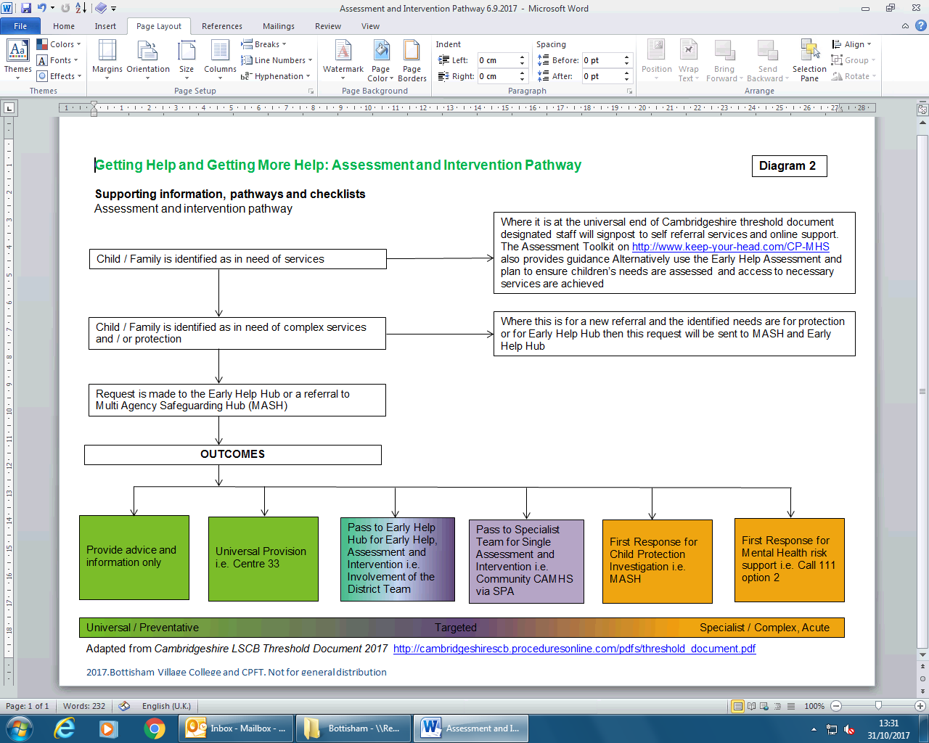

**Process for clarifying the nature of the Suicide Risk to determine response**

**Diagram 3**

**Disclosure of Risk**

**(suicide or deliberate self-harm)**

**Previously undisclosed acts and intrusive thoughts**

**Intrusive thoughts and feeling unsafe:**

* Unable to stop thinking about hurting them self
* Feels they cannot keep themselves safe

**Current and active plans:**

* Eg: Ligature, Overdose, cutting to the point of needing medical attention, other risk behaviours
* Taking steps to enact the plans
* Having specific details and plans on how or when they might do this
* Evidence of research and interest in suicide/ death

**What to think:**

* Don’t assume anything • Be compassionate and non- judgmental
* Take all risk seriously • Be honest if you don’t know what the answer is

**What to do:**

Explain what you will do with the information (in accordance with your guidelines about confidentiality)

Collate information. Get details about the disclosure by asking open questions:

* When did you start feeling like this? • What might have triggered this?
* How often? • Is there a pattern?
* How distressing is this for you? (scale 1-10 ) • What help do you think you need?
* Do you feel able to keep yourself safe? • Are your parents / carers aware?
* What keeps you safe?
* Who have you talked to about this?

**IN SCHOOL:**

* Discuss with designated person
* Log Concern
* Contact appropriate external agency

**EXTERNAL AGENCY REFERRAL:**

* CAMHS on-call: (**Brookside: 01223 465100**) during office hours if needing to be seen within 24-48 hours
* Single Point of Access (**SPA- 01480 428115**) during office hours for advice
* GP Surgery / Walk in Centre: Bloods and appointments.
* First Response Service (**FRS 111#2**): 24 hour service
* Local A&E for emergency help / treatment

**Follow up**

* Meeting with designated staff
* Debrief and next steps
* Safety planning
* Support for affected students
* Review, amend and share any changes

**Glossary of terms**

**PSHE** Personal, social, health and economic education

**SRE** Sex and relationship education

**SENCo** Special Educational needs co-ordinator

**HOL** Head of learning

**CLT** College leadership team

**CAMHS** Child and Adolescent Mental Health Services. (NB this term can be used both to refer to “comprehensive CAMHS” i.e. all organisations which work with children and therefore have a responsibility for their emotional wellbeing and also Community CAMHS, the specialist service.)

**SPA** Single Point of Access

**EHH** Early Help Hub

**MASH** Multi-agency safe-guarding hub

**LSCB** Local safeguarding children board

**SEND** Special educational needs and disability

**CPFT** Cambridge and Peterborough NHS Foundation Trust



1. Source: [Young Minds](http://www.youngminds.org.uk/training_services/policy/mental_health_statistics)